

**Programming Method**

**Module Title**

**Air Pollution**

**DYNAMIC WEBSITES**

**Assignment Title**

**Winter 2020**

**Examination Cycle**

**EI SHUNE LE THA**

**Candidate Name**

**Candidate No**

**KMD Institute (Yangon)**

**Centre Name**

**Submission Date:**

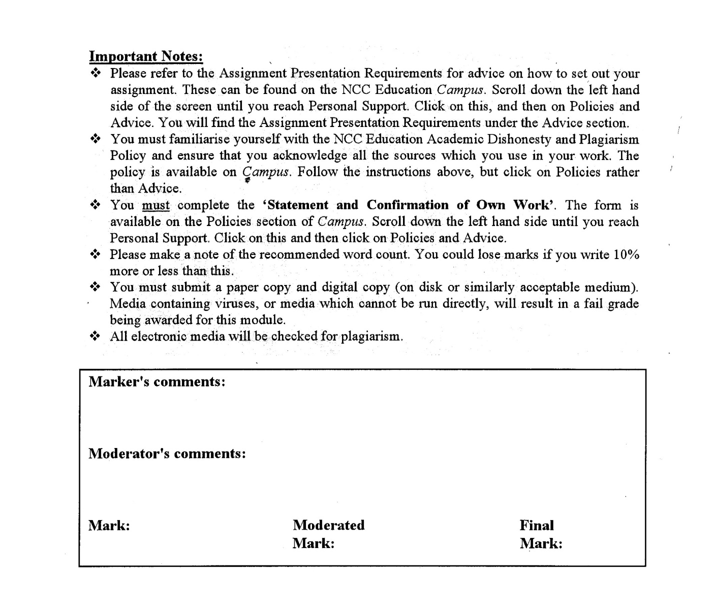



**Statement and Confirmation of Own Work**

**Programmed/Qualification Name: L5DC**

*All NCC Education assessed assignments submitted by students must have this statement as the cover page or it will not be accepted for marking. Please ensure that this statement is either firmly attached to the cover of the assignment or electronically inserted into the front of the assignment.*

**Student declaration**

I have read and understood NCC Education’s Policy on Academic Dishonesty and Plagiarism.

I can confirm the following details:

**Student ID/Registration number :**

**Name : EI SHUNE LE THA  
Centre Name : KMD Institute (Yangon)**

**Module Name : DYNAMIC WEBSITES  
Module Leader : SHAIN THU  
Number of words : [] words**

I confirm that this is my own work and that I have not plagiarised any part of it. I have also noted the assessment criteria and pass mark for assignments.

**Due Date : 2020  
Student Signature : SHUNE**

**Submitted Date :**

# Introduction

Regarding to the growth of air pollution which becomes a threat to people health for both short term and long term, the Air Pollution is website will be created. In this website, there will be lots of information about air pollution, which include the data of air pollution levels now and in the past of the United states of America.

This website should be the dynamic website which adapts to preferences of users also known as admins in this website for example, including an automatically running background video. Moreover, it need to be responsive as the customers also known as users will be able to operate this website on every device and besides, there will be different social media buttons so that the users can visit the social media page of Air Pollution organization. Then, there must be register page and login page to store personal information for those users who are interested in this website. In this case, a database will be created to store those information such as their name, password, address etc. Besides, those information will be able to be edited by the users themselves.

Furthermore, this website needs to contain search engine optimization for the convenience of users in searching the contents they want and also the attractive images with at least two media links of other relevant pollution websites. Also, the call action buttons for example, the campaign programs for the users to participate and the sign-up buttons for the users to keep up with the updates need to be included with the websites which each of them need to be located on the landing page and need to be eye-catching as well. And the website needs to have a function offer the users a free home pollution test kit after they have joined the campaigns.

In addition, after logging in, the users need to be able to view their account, change password and update their information.

**Task 1**

# Task – 1

## Analysis

In this task, landing pages for the Air Pollution website need to be created that include an attractive caption on a clean and colorful backdrops, clean colorful backgrounds, eye-attracting images, scroll-triggered animations, automatically loading background video, fluid layout, animated and interactive social media buttons, two media links of other relevant air pollution websites and a function that offers the users free home pollution test-kits.

## Assumptions

First of all, in every pages of this website, there will be a teal color website titles with clean white title backgrounds which is made for those users who are sensitive to view the multicolored contents. In some pages for example, home page, author’s posts page, city page and campaign page, there will be clean white background with the colorful texts with the purpose of avoiding the shamble contents and the rest will be with attracting image backgrounds.

Under the titles of every page, there will be navigation bars with links to multiples of pages, changing color when users put their cursor over each link, allowing the users to visit whatever page they want to go. Then, on the top of the home page, there will be a background video about air pollution that is running automatically in loop. Below the video, information about air pollution will be displayed with eye-catching images related to each content in every content row.

There will be social media buttons on the left side of the webpages which will be placed as fixed in that position so that the users do not have to scroll to the place where the social media buttons exist. There will be campaign links on the video and on the scroll triggered which will send the users to the campaign page when they click those links, allowing the users to view and choose whichever campaign they want to join. When the users choose to join their preferred campaign, they will get a free home pollution kit which will be delivered to their address.

In addition, there will be links to the relevant pollution websites both in the home page and in the city page which will be helpful for those users who want to research more about air pollution.

## Class Diagram

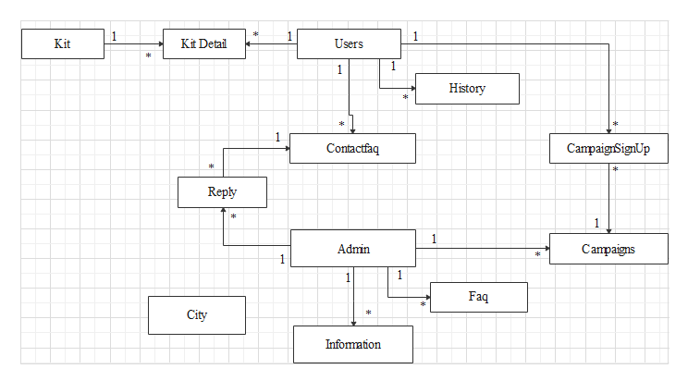

## Database Design

Table Name – Users

Description – This table is created with the purpose of keeping the personal information of the customers known as users.

|  |  |  |  |
| --- | --- | --- | --- |
|  | | | |
| **Column Name** | **Data Type** | **Field Size** | **Description** |
| User ID | integer | 11 | To store unique identification number of users |
| User Name | varchar | 100 | To store the user names of users |
| First Name | varchar | 100 | To store the first names of users |
| Last Name | varchar | 100 | To store the last names of users. |
| Email | varchar | 255 | Email of users |
| Password | varchar | 100 | Password of users |
| Date Of Birth | varchar | 100 | To store date of births of users |
| Address | varchar | 255 | To store the addresses of users. |
| Post Code | integer | 11 | To store the post codes of the users. |

Table Name – Admin

Description – This table is created to store all the information of the admins.

|  |  |  |  |
| --- | --- | --- | --- |
| **Column Name** | **Data Type** | **Field Size** | **Description** |
| Admin ID | integer | 11 | To store the unique identification numbers of admins. |
| Admin Name | varchar | 100 | To store the real names of admins |
| User Name | varchar | 100 | To store the user names of admins. |
| Email | varchar | 255 | To store the emails of admins. |
| Password | varchar | 100 | To store the passwords for admins with the purpose of security measures. |

Table Name – Campaigns

Description – To store all the campaigns created by the company.

|  |  |  |  |
| --- | --- | --- | --- |
| **Column Name** | **Data Type** | **Field Size** | **Description** |
| CampaignID | integer | 11 | To store the unique identification number of campaigns. |
| Campaign Title | varchar | 255 | To store the titles of the campaigns |
| Description | varchar | 255 | Descriptions about the campaign. |
| Image | varchar | 255 | To keep the poster of the campaign. |

Table Name – CampaignSignUp

Description – This table is created to keep the records of which users joined which campaigns.

|  |  |  |  |
| --- | --- | --- | --- |
| **Column Name** | **Data Type** | **Field Size** | **Description** |
| UserID | integer | 11 | To store the id of users who joined the campaigns. |
| CampaignID | integer | 11 | To store the id of campaigns that the users joined. |
| Date | date | - | To store the dates that the users joined the campaigns |

Table Name – Cities

Description – To store the information of cities inserted by the admins.

|  |  |  |  |
| --- | --- | --- | --- |
| **Column Name** | **Data Type** | **Field Size** | **Description** |
| City ID | integer | 11 | Unique identification numbers of cities. |
| City Name | varchar | 255 | To store the name of cities. |
| City Image | varchar | 255 | Images of cities in America. |
| Description | varchar | 255 | To store the description of each city. |
| Population | varchar | 30 | Population of each city. |
| Pollution Rate | varchar | 255 | Air pollution rate of each city. |
| Area | varchar | 255 | The location of the cities. |
| Main Attraction | varchar | 255 | The main attractions of each city. |
| Date | varchar | 255 | The date when the users insert the cities. |

Table Name – Contact Faq

Description – This table is made with the purpose of keeping the questions about air pollution that the users asked.

|  |  |  |  |
| --- | --- | --- | --- |
| **Column Name** | **Data Type** | **Field Size** | **Description** |
| Question ID | integer | 11 | Unique identification number of questions. |
| Question | varchar | 255 | The questions that the users asked. |
| UserID | integer | 11 | The IDs of the users who asked the questions. |

Table Name – faq

Description – to store the frequently asked questions that the admins made by themselves.

|  |  |  |  |
| --- | --- | --- | --- |
| **Column Name** | **Data Type** | **Field Size** | **Description** |
| FaqID | integer | 11 | Unique identification numbers of Faqs. |
| AdminID | integer | 11 | IDs of admins who wrote the faqs. |
| Question | varchar | 255 | Questions that are created by admins themselves. |
| Answer | varchar | 255 | Answers to perspective questions. |

Table Name – History

Description – To store the search histories of each users.

|  |  |  |  |
| --- | --- | --- | --- |
| **Column Name** | **Data Type** | **Field Size** | **Description** |
| History ID | Integer | 11 | To store the unique identification numbers of each search history. |
| UserID | integer | 11 | To store the IDs of users who searched the contents. |
| SearchData | varchar | 255 | The searched data of each users. |
| Date | date | - | Dates that the users searched for the contents. |

Table Name – Information

Description – To store the posts that the admins wrote related to air pollution.

|  |  |  |  |
| --- | --- | --- | --- |
| **Column Name** | **Data Type** | **Field Size** | **Description** |
| Info ID | integer | 11 | Unique identification numbers of the posts |
| Title | varchar | 255 | Titles of each posts. |
| Image | varchar | 255 | Images of each posts. |
| Content | varchar | 255 | Contents of each posts. |
| AdminID | integer | 11 | To store the IDs of admins who wrote the posts. |
| Date | date | - | To keep the dates when the admins wrote the posts. |

Table Name – Kits

Description – To store the information of the kits that are to be gifted to the users who joined the campaigns.

|  |  |  |  |
| --- | --- | --- | --- |
| **Column Name** | **Data Type** | **Field Size** | **Description** |
| KitID | integer | 11 | Unique identification numbers of kits. |
| KitName | Varchar | 255 | To store the names of each kits. |
| Accessories | varchar | 255 | To store the data of accessories contained in the kit. |
| Description | varchar | 255 | Description of each kits. |
| KitImage | varchar | 255 | Images of each kits. |

Table Name – Kit Detail

Description – To store the detail of which user got the kit and their information.

|  |  |  |  |
| --- | --- | --- | --- |
| **Column Name** | **Data Type** | **Field Size** | **Description** |
| UserID | integer | 11 | ID of users who got the kits. |
| KitID | integer | 11 | ID of kits that are given to users. |
| Delivery Address | varchar | 255 | Address of users who got the kit. |
| Date | date | - | The date when the users got the kits. |

Table Name – Reply

Description – This table is created to store the replies from the admins to the questions asked by the users.

|  |  |  |  |
| --- | --- | --- | --- |
| **Column Name** | **Data Type** | **Field Size** | **Description** |
| Reply ID | integer | 11 | Unique identification numbers of replies. |
| Admin ID | integer | 11 | To store the ids of admins who answered the questions. |
| Question ID | integer | 11 | To store the ids of questions asked by the users. |
| Answer | varchar | 255 | To store the answers to each questions answered by the admins. |
| Reply Date | date | - | To store the dates when the admins answered the questions. |

## Screen Design

**Homepage.php**

Automatically loading background video

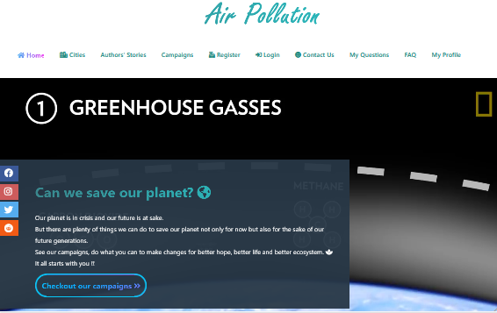

Compelling caption against clean colorful backdrop



Clean colorful backdrop

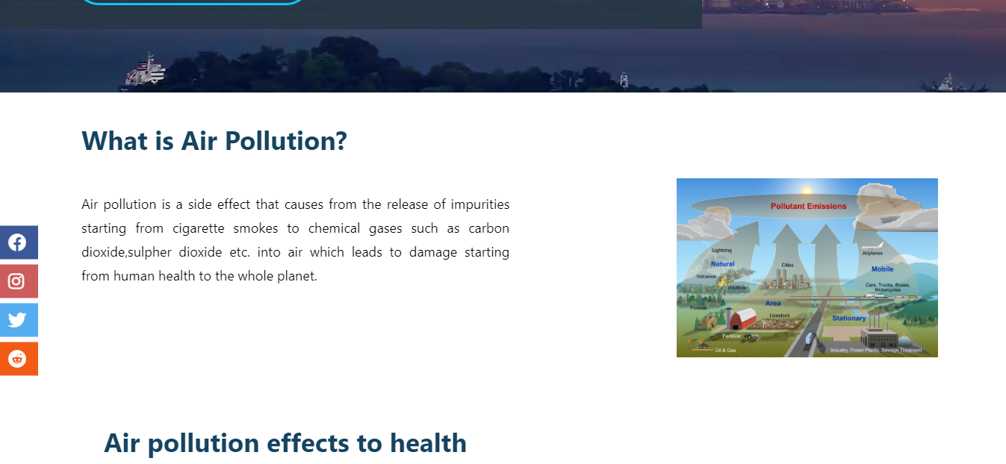

Animated/interactive social media buttons or navigation buttons

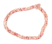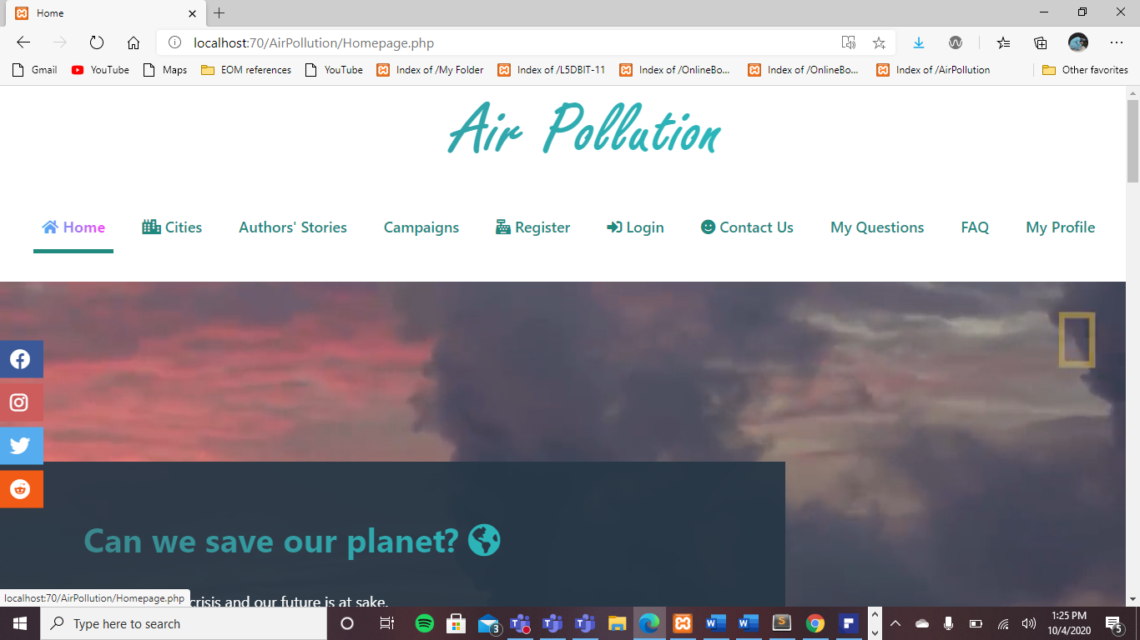

Call to action button



Media link to relevant pollution website

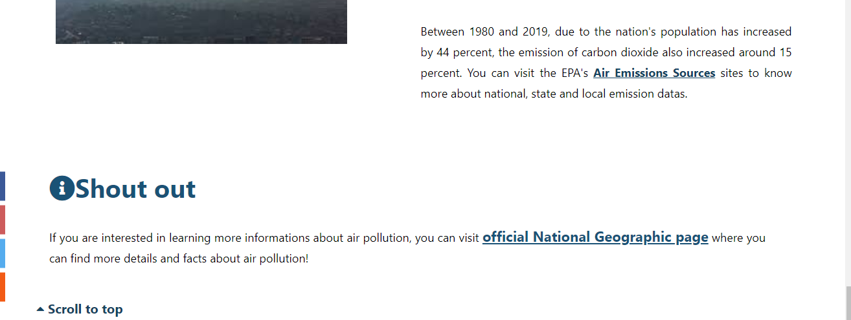

**CityDisplay.php**

Eye catching images

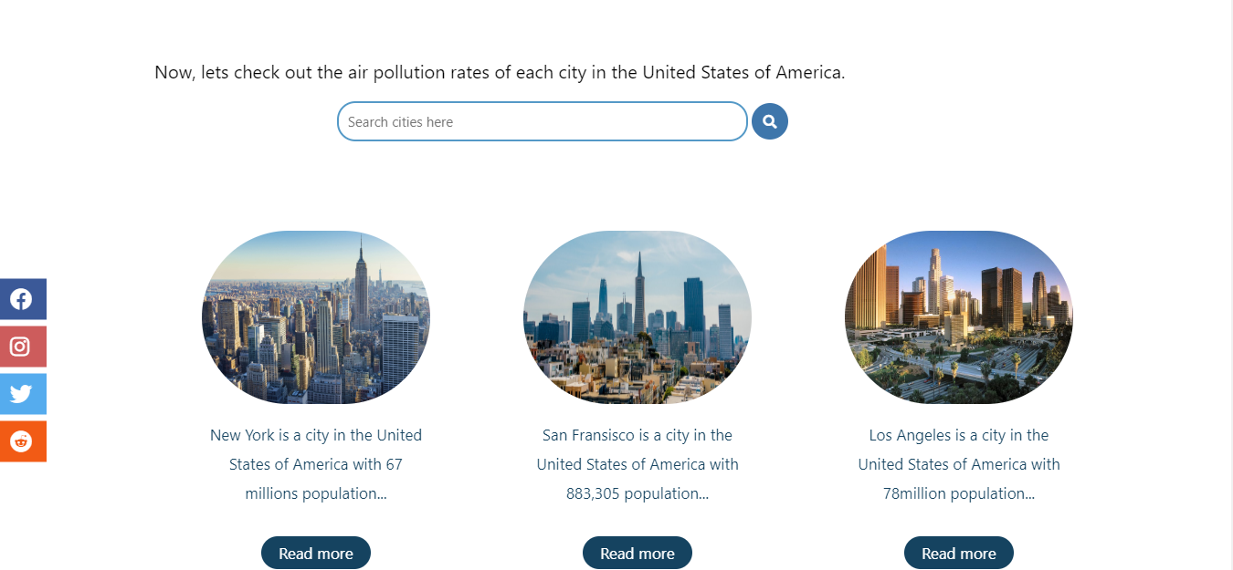

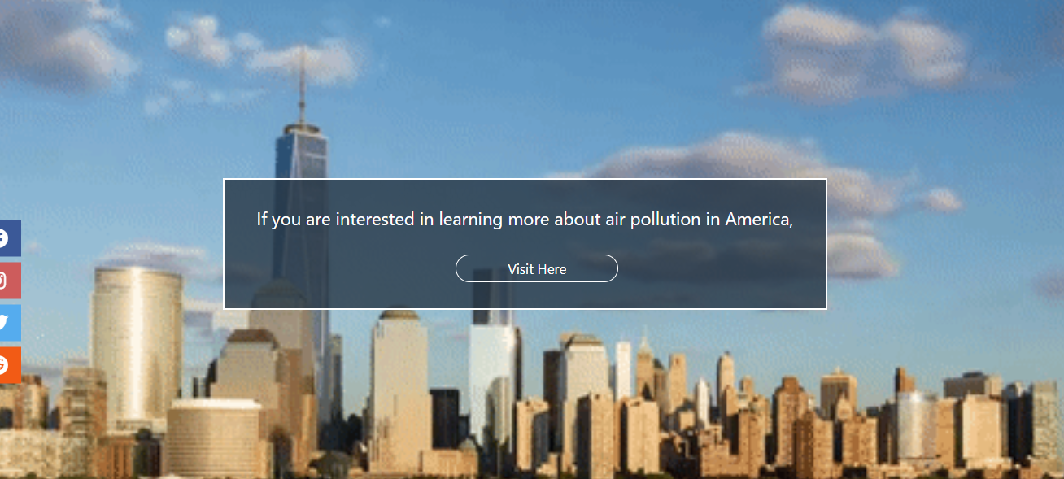

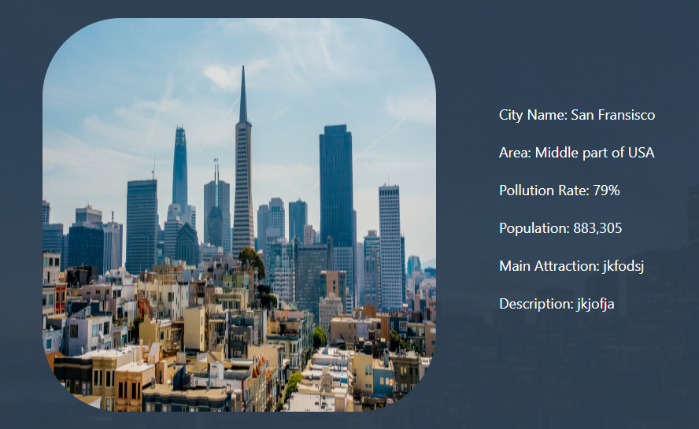

Fluid layout

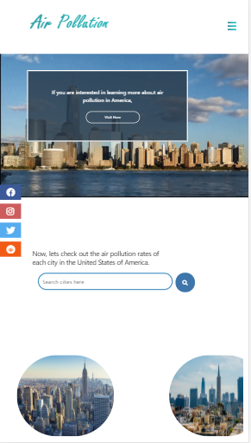

Media link to relevant pollution website



**Homepage2.php**

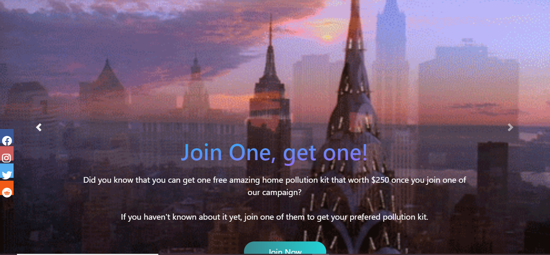

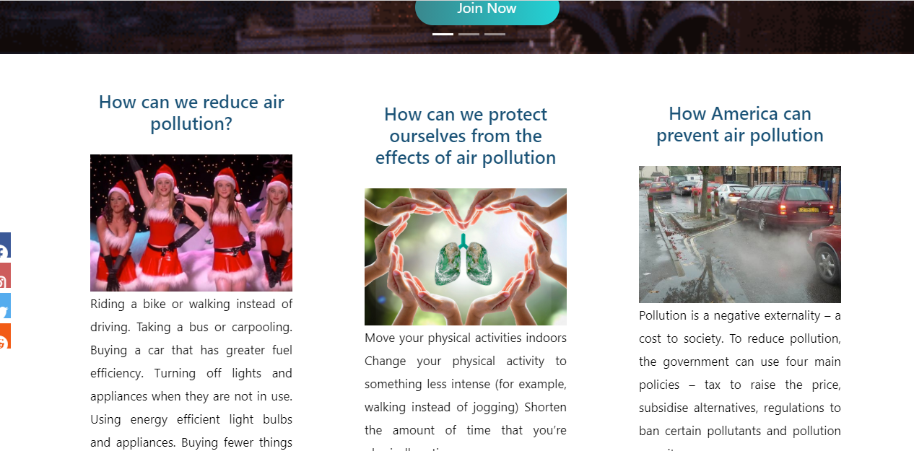

Scroll triggered animations

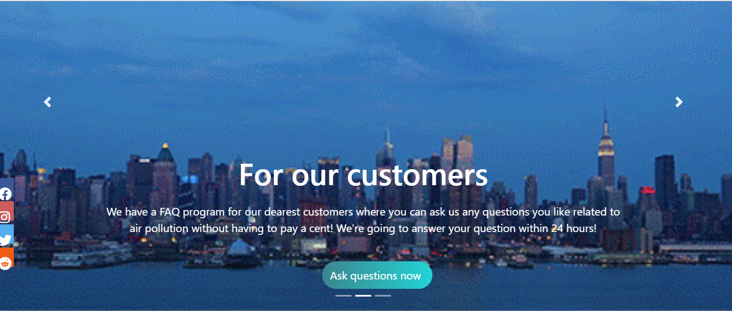

Eye catching images

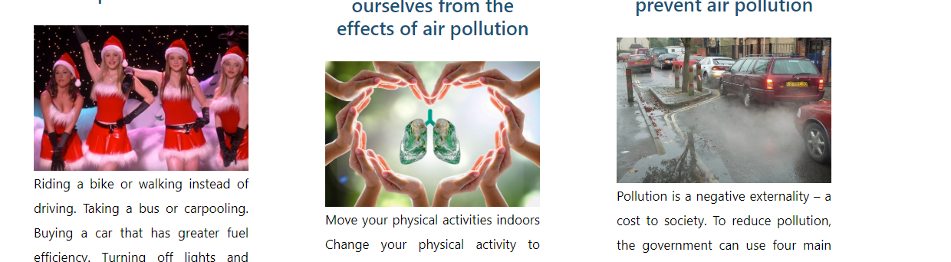

An offer of a free home pollution testing kit pop-up button for signing up



**Campaigns.php**

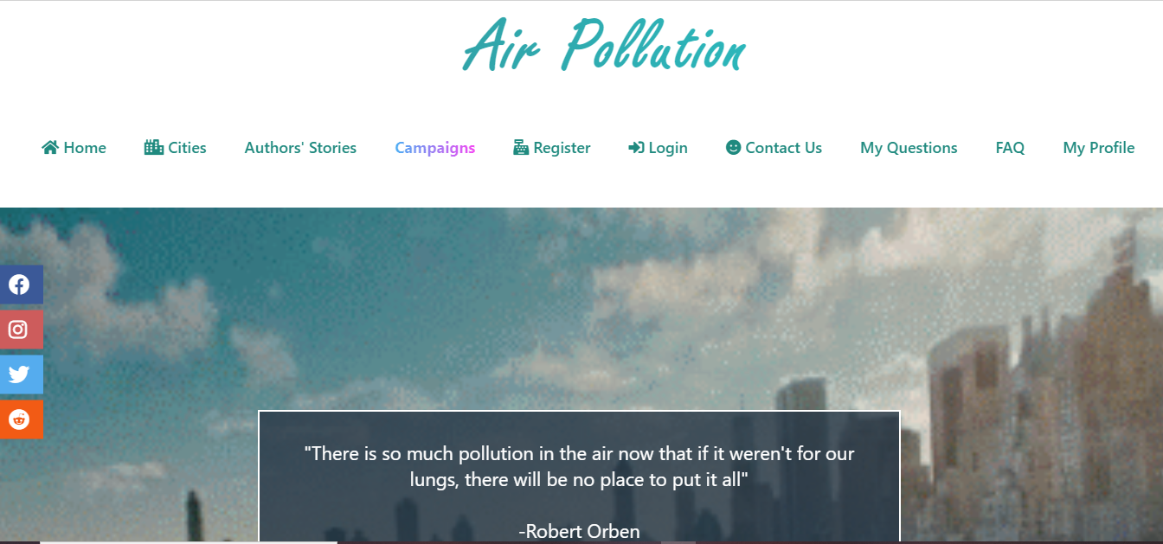

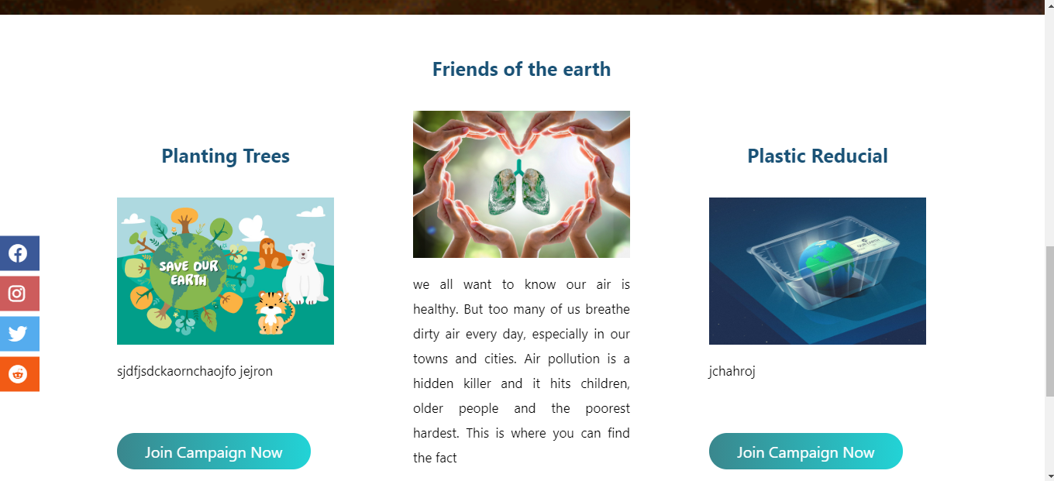

## Coding

**Homepage.php**

<?php

include('Connect.php');

$select="Select * from information i, admin a where i.AdminID=a.AdminID";

$selrun=mysqli_query($connect,$select);

$count=mysqli_num_rows($selrun);

?>

<html>

<head>

<meta charset="utf-8">

<title>Home</title>

<link rel="stylesheet" type="text/css" href="Style.css">

<meta name="viewport" content="width=device-width, intial-scale=1.0">

<script src="https://kit.fontawesome.com/c8fd1d96f9.js" crossorigin="anonymous"></script>

</head>

<body class="">

<div class="page">

<div class="head">

<h1 class="title">Air Pollution</h1>

<input type="checkbox" id="chk">

<label for="chk" class="show-menu-btn">

<i class="fas fa-bars"></i>

</label>

<ul class="menu">

<a href="Homepage.php"><span><i class="fas fa-home"></i> Home</span></a>

<a href="CityDisplay.php"> <i class="fas fa-city"></i> Cities</a>

<a href="Homepage2.php">Authors' Stories</a>

<a href="Campaigns.php">Campaigns</a>

<a href="UserRegister.php"><i class="fas fa-cash-register"></i> Register</a>

<a href="UserLogin.php"> <i class="fas fa-sign-in-alt"></i> Login</a>

<a href="ContactUs.php"><i class="fas fa-smile"></i> Contact Us</a>

<a href="MyQuestions.php">My Questions</a>

<a href="FaqDisplay.php">FAQ</a>

<a href="viewprofile.php">My Profile</a>

<label for="chk" class="hide-menu-btn">

<i class="fas fa-times-circle"></i>

</label>

</ul>

</div>

</div>

<div class="page5">

<div class="jenga">

<video autoplay muted loop>

<source src="Images/airpollution.mp4" type="video/mp4" >

</video>

<div class="idk">

<h2>Can we save our planet? <i class="fas fa-globe-americas"></i></h2>

<p>Our planet is in crisis and our future is at sake. <br> But there are plenty of things we can do to save our planet not only for now but also for the sake of our future generations. <br>

See our campaigns, do what you can to make changes for better hope, better life and better ecosystem. <i class="fas fa-spa"></i> <br>

It all starts with you !! <br> <br>

<a href="Campaigns.php">Checkout our campaigns <i class="fas fa-angle-double-right"></i></a>

</p>

</div>

</div>

</div>

<div class="icons">

<ul>

<a href="https://www.facebook.com/"><li class="facebook"><i class="fab fa-facebook"></i></li></a>

<a href="https://www.instagram.com/"><li class="instagram"><i class="fab fa-instagram"></i></li></a>

<a href="https://twitter.com/"><li class="twitter"><i class="fab fa-twitter"></i></li></a>

<a href="https://www.redditinc.com/"><li class="reddit"><i class="fab fa-reddit"></i></li></a>

</ul>

</div>

<!-- <div class="author">

<a href="Homepage2.php">Check out our Authors' posts <i class="fas fa-angle-double-right"></i></a>

</div> -->

<div class="pollution">

<div class="army">

<h2>What is Air Pollution?</h2>

<p>

Air pollution is a side effect that causes from the release of impurities starting from cigarette smokes to chemical gases such as carbon dioxide,sulpher dioxide etc. into air which leads to damage starting from human health to the whole planet. <br> <br>

</p>

<img src="Images/Sources_Graphic_Huge.jpg" width="300" heigth="100">

</div>

<div class="holo">

<h2> Air pollution effects to health</h2>

<p> Having a polluted air is not only health damaging, but also is fatal. According to National geographic organization(NGO) and World Health Organization(WHO), on 2016, 4.2 million population died and 90 percent of them was from middle-income countries. Indoor smoke which causes from cooking, smoking and heating with coal, kerosene and burning biomass etc. became a threat to the health of 3 billion people around the world.

In some cases, it has been stated that most lung cancers, heart diseases, stroke and asthema etc. are the consequences of having a air polluted environment.

</p>

<img src="Images/ap health.png" >

</div>

<div class="regina">

<h2>Air pollution effects to mother nature</h2>

<p>

Along side with human health, air pollution can bring lots of climate damages such as acid raining, eutrophication and haze etc. Like humans, animals may also experience lots of health problems from breathing the polluted air. According to the researches, breathing a large amount of toxic air causes birth defects, reproduction faliure and chronic illnesses.

</p>

<img src="Images/Atmospheric-pathway-of-air-pollution.png">

</div>

<div class="america">

<h2>Air Pollution in America</h2>

<p>

Iregardless, the effects of the air pollution differs from one place to another around the world. In United States of America, the air pollution had started since the inception of Industrial Revolution. <br><br>

According to the researches, America has been facing with 100000 popoulation of death each year because of air pollution. After a bunch of decades, America's air quality cannot be getting any cleaner. <br> <br>

Thanks to the EPA's air toxics program, the nation's air pollutant concentration declined to around 98 percent on around 1990 to 2005.

According to federal datas, America has been experencing with more air polluted days than recent years ago. Around 1980s, the nation's air pollution rate was around 20% and after passing a few decades, around 2013 to 2019 the nation had experienced 15% more days of air pollution than 1980s. These increasing of air pollution mostly comes from the increasement of the useage of vehicles, chemical gases from factories and from other sources. <br><br>

Between 1980 and 2019, due to the nation's population has increased by 44 percent, the emission of carbon dioxide also increased around 15 percent.

You can visit the EPA's <a href="https://www.epa.gov/air-emissions-inventories/air-emissions-sources">Air Emissions Sources</a> sites to know more about national, state and local emission datas. <br> <br>

</p>

<img src="Images/3000.jpeg">

<img src="Images/download.jpg">

</div>

</div>

<!--

-->

<div class="reminder">

<h2><i class="fas fa-info-circle"></i>Shout out</h2>

<p> If you are interested in learning more informations about air pollution, you can visit <a href="https://www.nationalgeographic.com/environment/global-warming/pollution/">official National Geographic page</a> where you can find more details and facts about air pollution!

</p>

</div>

<div class="trinity">

<a href="Homepage.php" class="top"><i class="fas fa-caret-up"></i> Scroll to top</a> <br><br>

<a href="UserRegister.php"> <input type="button" class="yall" value="Sign-up for free"></a>

<a href="CityDisplay.php"><input type="button" class="cd" value="Check out Cities"></a>

</div>

</body>

<footer class="page">

<p>CopyRight&copy;www.airpollution.com All Right Reserved | Privacy and terms of use | <a href="#"><i class="fas fa-at"></i> Email us</a></p>

</footer>

</html>

**CityDisplay.php**

<?php

session_start();

include('Connect.php');

$Select="Select * from cities";

$selrun=mysqli_query($connect,$Select);

$crow=mysqli_num_rows($selrun);

if (isset($_REQUEST['btnsearch']))

{

$Search=$_REQUEST['txtsearch'];

$sel="Select * from cities where CityName like'%$Search%'";

$selrun=mysqli_query($connect,$sel);

$crow=mysqli_num_rows($selrun);

if (isset($_SESSION['UID']))

{

$userid=$_SESSION['UID'];

$search=$_REQUEST['txtsearch'];

$date=date('Y-m-d');

$insert="Insert into history (UserID,SearchData,Date) values('$userid','$search','$date')";

$insertrun=mysqli_query($connect,$insert);

}

}

?>

<html>

<head>

<meta charset="utf-8">

<title>Cities</title>

<link rel="stylesheet" type="text/css" href="Style.css">

<meta name="viewport" content="width=device-width, intial-scale=1.0">

<script src="https://kit.fontawesome.com/c8fd1d96f9.js" crossorigin="anonymous"></script>

</head>

<body>

<div class="page2">

<div class="head">

<h1 class="title">Air Pollution</h1>

<input type="checkbox" id="chk">

<label for="chk" class="show-menu-btn">

<i class="fas fa-bars"></i>

</label>

<ul class="menu">

<a href="Homepage.php"><i class="fas fa-home"></i> Home</a>

<a href="CityDisplay.php"><span><i class="fas fa-city"></i> Cities</span></a>

<a href="Homepage2.php">Authors' Stories</a>

<a href="Campaigns.php">Campaigns</a>

<a href="UserRegister.php"><i class="fas fa-cash-register"></i> Register</a>

<a href="UserLogin.php"> <i class="fas fa-sign-in-alt"></i> Login</a>

<a href="ContactUs.php"><i class="fas fa-smile"></i> Contact Us</a>

<a href="MyQuestions.php">My Questions</a>

<a href="FaqDisplay.php">FAQ</a>

<a href="viewprofile.php">My Profile</a>

<label for="chk" class="hide-menu-btn">

<i class="fas fa-times-circle"></i>

</label>

</ul>

</div>

<div class="banner">

<img src="Images/newyork.gif">

<p >

If you are interested in learning more about air pollution in America, <br> <br>

<a href="https://gispub.epa.gov/air/trendsreport/2019/#home"><input type="button" value="Visit Here" class="visit"></a>

</p>

</div>

</div>

<div class="cities">

<p class="co">Now, lets check out the air pollution rates of each city in the United States of America. </p>

<div class="koo">

<form action="" method="post">

<input type="text" class="kootxt" name="txtsearch" placeholder="Search cities here">

<button type="submit" class="koobtn" name="btnsearch"><i class="fas fa-search"></i></button>

</form>

</div>

<div class="icons">

<ul>

<a href="https://www.facebook.com/"><li class="facebook"><i class="fab fa-facebook"></i></li></a>

<a href="https://www.instagram.com/"><li class="instagram"><i class="fab fa-instagram"></i></li></a>

<a href="https://twitter.com/"><li class="twitter"><i class="fab fa-twitter"></i></li></a>

<a href="https://www.redditinc.com/"><li class="reddit"><i class="fab fa-reddit"></i></li></a>

</ul>

</div>

<div class="camila">

<?php

if ($crow==0)

{

echo "<p>No cities found.</p>";

}

?>

<div class="prada">

<table class="alvin">

<?php

for ($i=0; $i <$crow ; $i+=3)

{

echo "<tr>";

if (isset($_REQUEST['btnsearch']))

{

$csel2="Select * from cities where CityName like '%$Search%' limit $i,3";

$cselrun=mysqli_query($connect,$csel2);

$cselcount=mysqli_num_rows($cselrun);

}

else

{

$csel2="Select * from cities limit $i,3";

$cselrun=mysqli_query($connect,$csel2);

$cselcount=mysqli_num_rows($cselrun);

}

for ($j=0; $j <$cselcount ; $j++)

{

$cfetch=mysqli_fetch_array($cselrun);

$cname=$cfetch['CityName'];

$cimg=$cfetch['CityImage'];

$pop=$cfetch['Population'];

$cid=$cfetch['CityID'];

echo "<td>";

?>

<img src="<?php echo $cimg ?>"> <br>

<p><?php echo $cname ?> is a city in the United States of America with <?php echo $pop ?> population...<br><br>

<a href="CityDetail.php?CID=<?php echo $cid ?>"><input type="button" class="camilabtn" value="Read more" class="camilabtn"></a>

</p>

<?php

echo "</td>";

}

echo "</tr>";

}

?>

</table>

</div>

</div>

</div>

<div id="map" style="width:400px; height: 400px; margin-left:50px " >

<script src="http://maps.googleapis.com/maps/api/js?sensor=false"></script>

<script>

var myMap;

var myLatlng = new google.maps.LatLng(37.090240,-95.712891);

function initialize() {

var mapOptions = {

zoom: 5,

center: myLatlng,

mapTypeId: google.maps.MapTypeId.ROADMAP ,

scrollwheel: false

}

myMap = new google.maps.Map(document.getElementById('map'), mapOptions);

// var marker = new google.maps.Marker({

// position: myLatlng,

// map: myMap,

// title: 'Name Of Business',

// icon: 'http://www.google.com/intl/en_us/mapfiles/ms/micons/red-dot.png'

// });

}

google.maps.event.addDomListener(window, 'load', initialize);

</script>

</div>

</div>

</body>

<div class="page2">

<footer>

<p>CopyRight&copy;www.airpollution.com All Right Reserved | Privacy and terms of use | <a href="#"><i class="fas fa-at"></i> Email us</a></p>

</footer>

</div>

</html>

**Homepage2.php**

<?php

include('Connect.php');

$select="Select * from information i, admin a where i.AdminID=a.AdminID";

$selrun=mysqli_query($connect,$select);

$count=mysqli_num_rows($selrun);

?>

<html>

<head>

<title>From our Authors</title>

<link rel="stylesheet" type="text/css" href="Style.css">

<meta name="viewport" content="width=device-width, intial-scale=1.0">

<script src="https://kit.fontawesome.com/c8fd1d96f9.js" crossorigin="anonymous"></script>

<!-- CSS only -->

<link rel="stylesheet" href="https://stackpath.bootstrapcdn.com/bootstrap/4.5.2/css/bootstrap.min.css" integrity="sha384-JcKb8q3iqJ61gNV9KGb8thSsNjpSL0n8PARn9HuZOnIxN0hoP+VmmDGMN5t9UJ0Z" crossorigin="anonymous">

<!-- JS, Popper.js, and jQuery -->

<script src="https://code.jquery.com/jquery-3.5.1.slim.min.js" integrity="sha384-DfXdz2htPH0lsSSs5nCTpuj/zy4C+OGpamoFVy38MVBnE+IbbVYUew+OrCXaRkfj" crossorigin="anonymous"></script>

<script src="https://cdn.jsdelivr.net/npm/popper.js@1.16.1/dist/umd/popper.min.js" integrity="sha384-9/reFTGAW83EW2RDu2S0VKaIzap3H66lZH81PoYlFhbGU+6BZp6G7niu735Sk7lN" crossorigin="anonymous"></script>

<script src="https://stackpath.bootstrapcdn.com/bootstrap/4.5.2/js/bootstrap.min.js" integrity="sha384-B4gt1jrGC7Jh4AgTPSdUtOBvfO8shuf57BaghqFfPlYxofvL8/KUEfYiJOMMV+rV" crossorigin="anonymous"></script>

</head>

<body>

<!-- <div class="container-fluid"> -->

<div class="navMenu">

<div class="head">

<h1 class="title">Air Pollution</h1>

<input type="checkbox" id="chk">

<label for="chk" class="show-menu-btn">

<i class="fas fa-bars"></i>

</label>

<ul class="menu">

<a href="Homepage.php"><i class="fas fa-home"></i> Home</a>

<a href="CityDisplay.php"> <i class="fas fa-city"></i> Cities</a>

<a href="Homepage2.php"><span>Authors' Stories</span></a>

<a href="Campaigns.php">Campaigns</a>

<a href="UserRegister.php"><i class="fas fa-cash-register"></i> Register</a>

<a href="UserLogin.php"> <i class="fas fa-sign-in-alt"></i> Login</a>

<a href="ContactUs.php"><i class="fas fa-smile"></i> Contact Us</a>

<a href="MyQuestions.php">My Questions</a>

<a href="FaqDisplay.php">FAQ</a>

<a href="viewprofile.php">MyProfile</a>

<label for="chk" class="hide-menu-btn">

<i class="fas fa-times-circle"></i>

</label>

</ul>

</div>

</div>

<!-- </div> -->

<div class="icons">

<ul>

<a href="https://www.facebook.com/"><li class="fb"><i class="fab fa-facebook"></i></li></a>

<a href="https://www.instagram.com/"><li class="instagram"><i class="fab fa-instagram"></i></li></a>

<a href="https://twitter.com/"><li class="twitter"><i class="fab fa-twitter"></i></li></a>

<a href="https://www.redditinc.com/"><li class="reddit"><i class="fab fa-reddit"></i></li></a>

</ul>

</div>

<!-- <div class="container"> -->

<div id="carouselExampleCaptions" class="carousel slide" data-ride="carousel">

<ol class="carousel-indicators">

<li data-target="#carouselExampleCaptions" data-slide-to="0" class="active"></li>

<li data-target="#carouselExampleCaptions" data-slide-to="1"></li>

<li data-target="#carouselExampleCaptions" data-slide-to="2"></li>

</ol>

<div class="carousel-inner">

<div class="carousel-item active">

<img src="Images/nyc.gif" class="d-block w-100" alt="...">

<div class="carousel-caption d-none d-md-block" >

<h1 id="billie" style="background:linear-gradient(to bottom right, #08C9F9,#C54AF3 );

-webkit-text-fill-color:transparent;

-webkit-background-clip:text;font-size:55px; padding-bottom:13px">Join One, get one!</h1>

<p id="shake"> Did you know that you can get one free amazing home pollution kit that worth $250 once you join one of our campaign? <br> <br>If you haven't known about it yet, join one of them to get your prefered pollution kit. </p>

<a href="Campaigns.php"><input class="button" type="button" value="Join Now"></a>

</div>

</div>

<div class="carousel-item">

<img src="Images/thriller.gif" class="d-block w-100" alt="...">

<div class="carousel-caption d-none d-md-block">

<h1 id="billie" style="color:white;text;font-size:55px; padding-bottom:13px">For our customers</h1>

<p id="shake">We have a FAQ program for our dearest customers where you can ask us any questions you like related to air pollution without having to pay a cent! We're going to answer your question within 24 hours!</p>

<a href="ContactUs.php"><input class="button" type="button" value="Ask questions now "></a>

</div>

</div>

<div class="carousel-item">

<img src="Images/chicago.gif" class="d-block w-100" alt="...">

<div class="carousel-caption d-none d-md-block">

<h1 id="billie">FAQ program</h1>

<p id="shake">Recently, we have recieved lots of air pollution questions from our customers so we have created a new Faq page where you can search for questions and answers you like to know for free! <br> If you are a student or a person who like to make researches about air pollution, we consider this program might be helpful to you :3! </p>

<a href="FaqDisplay.php"><input class="button" type="button" value="View Faqs "></a>

</div>

</div>

</div>

<a class="carousel-control-prev" href="#carouselExampleCaptions" role="button" data-slide="prev">

<span class="carousel-control-prev-icon" aria-hidden="true"></span>

<span class="sr-only">Previous</span>

</a>

<a class="carousel-control-next" href="#carouselExampleCaptions" role="button" data-slide="next">

<span class="carousel-control-next-icon" aria-hidden="true"></span>

<span class="sr-only">Next</span>

</a>

</div>

<!-- </div> -->

<div class="blonde">

<table class="alvin" >

<?php

for ($i=0; $i <$count ; $i+=3)

{

echo "<div class='kourtney'>";

echo "<tr>";

$select2="Select * from information i, admin a where i.AdminID=a.AdminID Limit $i,3";

$selrun2=mysqli_query($connect,$select2);

$count2=mysqli_num_rows($selrun2);

for ($g=0; $g < $count2; $g++)

{

$fetch=mysqli_fetch_array($selrun2);

$title=$fetch['Title'];

$content=$fetch['Content'];

$Name=$fetch['AdminName'];

$Date=$fetch['Date'];

$image=$fetch['Image'];

echo "<td>";

?>

<h2><?php echo $title ?></h2><br>

<img src="<?php echo $image ?>" width="200" height="170">

<p><?php echo $content ?></p><br>

<p>Author: <i> <?php echo $Name ?> </i> on <i><?php echo $Date ?></i></p>

<?php

echo "</td>";

}

echo "</tr>";

echo "</div>";

}

?>

</table>

</div>

</body>

<footer>

<p>CopyRight&copy;www.airpollution.com All Right Reserved | Privacy and terms of use | <a href="#"><i class="fas fa-at"></i> Email us</a></p>

</footer>

</html>

**Campaigns.php**

<?php

include('Connect.php');

$Select="Select * from campaigns";

$selrun=mysqli_query($connect,$Select);

$srow=mysqli_num_rows($selrun);

?>

<html>

<head>

<title>Campaigns</title>

<link rel="stylesheet" type="text/css" href="Style.css">

<meta name="viewport" content="width=device-width, intial-scale=1.0">

<script src="https://kit.fontawesome.com/c8fd1d96f9.js" crossorigin="anonymous"></script>

<body>

<div class="head">

<h1 class="title">Air Pollution</h1>

<input type="checkbox" id="chk">

<label for="chk" class="show-menu-btn">

<i class="fas fa-bars"></i>

</label>

<ul class="menu">

<a href="Homepage.php"><i class="fas fa-home"></i> Home</a>

<a href="CityDisplay.php"> <i class="fas fa-city"></i> Cities</a>

<a href="Homepage2.php">Authors' Stories</a>

<a href="Campaigns.php"><span>Campaigns</span></a>

<a href="UserRegister.php"><i class="fas fa-cash-register"></i> Register</a>

<a href="UserLogin.php"> <i class="fas fa-sign-in-alt"></i> Login</a>

<a href="ContactUs.php"><i class="fas fa-smile"></i> Contact Us</a>

<a href="MyQuestions.php">My Questions</a>

<a href="FaqDisplay.php">FAQ</a>

<a href="viewprofile.php">My Profile</a>

<label for="chk" class="hide-menu-btn">

<i class="fas fa-times-circle"></i>

</label>

</ul>

</div>

<div class="icons">

<ul>

<a href="https://www.facebook.com/"><li class="fb"><i class="fab fa-facebook"></i></li></a>

<a href="https://www.instagram.com/"><li class="instagram"><i class="fab fa-instagram"></i></li></a>

<a href="https://twitter.com/"><li class="twitter"><i class="fab fa-twitter"></i></li></a>

<a href="https://www.redditinc.com/"><li class="reddit"><i class="fab fa-reddit"></i></li></a>

</ul>

</div>

<div class="banner2">

<img src="Images/newyork2.gif">

<p>"There is so much pollution in the air now that if it weren't for our lungs, there will be no place to put it all"<br><br>

-Robert Orben

</p>

</div>

<div class="damien">

<table class="alvin" >

<?php

for ($i=0; $i <$srow ; $i+=3)

{

echo "<div class='kourtney'>";

echo "<tr>";

$select2="Select * from campaigns Limit $i,3";

$selrun2=mysqli_query($connect,$select2);

$count2=mysqli_num_rows($selrun2);

for ($g=0; $g < $count2; $g++)

{

$fetch=mysqli_fetch_array($selrun2);

$cid=$fetch['CampaignID'];

$title=$fetch['CampaignTitle'];

$description=$fetch['Description'];

$Image=$fetch['Image'];

echo "<td>";

?>

<h2><?php echo $title ?></h2><br>

<img src="<?php echo $Image ?>" width="200" height="170">

<p><?php echo $description ?></p><br>

<button class="sugar"><a href="CampaignSignUp.php?CID=<?php echo $cid ?>">Join Campaign Now</a></button>

<?php

echo "</td>";

}

echo "</tr>";

echo "</div>";

}

?>

</table>

</div>

</body>

<footer>

<p>CopyRight&copy;www.airpollution.com All Right Reserved | Privacy and terms of use | <a href="#"><i class="fas fa-at"></i> Email us</a></p>

</footer>

</html>

## Testing

**Test Case 1**

|  |  |
| --- | --- |
| Test objective | To create admin table |
| Test Data | AdminID int autoincrement  AdminName varchar 100  UserName varchar 100  Email varchar 255  Password varchar 255 |
| Test Procedure | A new admin table is created in the air pollution database. The admin table is inserted with the admin information shown above. Then the create page is operated. |
| Expected Result | The messages that says the tables are created and inserted must appear. |
| Actual Result | Can observed as below. |

Before Testing:

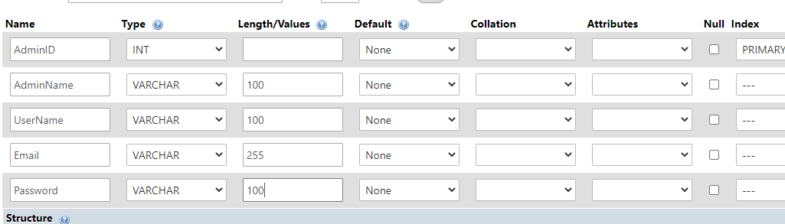

After Testing:

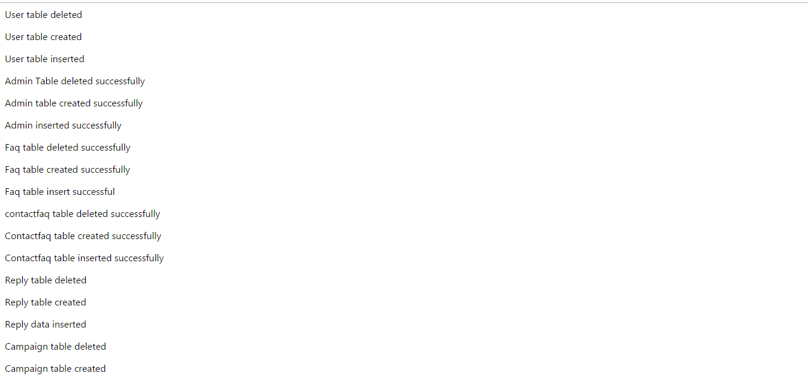

**Task 2**

# Task – 2

## Analysis

In this task, the registration form and login form for user, also known as customers in this website which include the user name, password and other personal details about each user should be created. In this case, the user’s passwords must be hashed as the security measure. Then, when the users login to the website and if they fail for 3 times, they should be locked for 10 minutes. In addition, the user names and user passwords should be checked if they have already existed in the database when the new users register into the website.

## Assumptions

Firstly, the User register page that includes User Name, First and last name, user email, password, Date of birth, Address and post code will be created. In this case, passwords that the users filled up will be hashed for the security measure to protect the passwords from unauthorized users. Next, the User Login page will be created where the users must fill up the User Name and Password to have access to the website with their own account. When the users fail to login for the first and second time, a message box will appear informing the users that they have filled up the wrong password. But when the users fail for the third time, they will be locked for 10 minutes straight and after 10 minutes, they will be able to fill up the login form again. In addition, in the register form, the user name, password and email will be checked and if they have already existed in the database an alert box will appear saying the user’s information has already existed and besides, when the users forget to fill one of the text boxes, the error message that inform users to fill all text boxes will appear.

## Screen Design

UserRegister.php

, 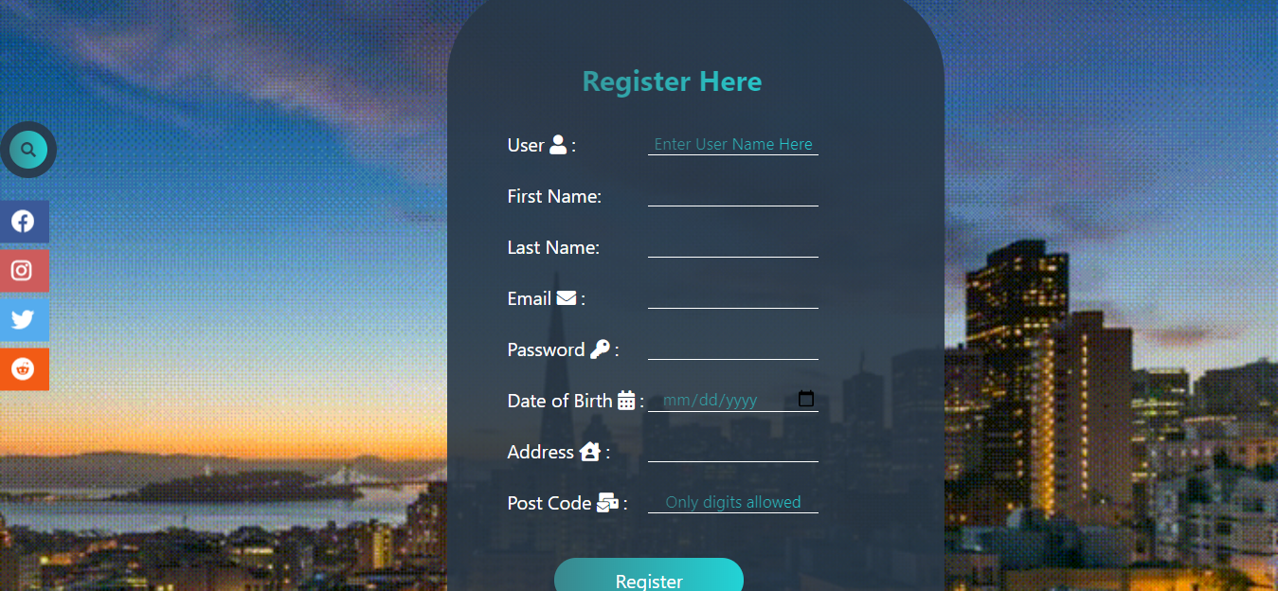

UserLogin.php

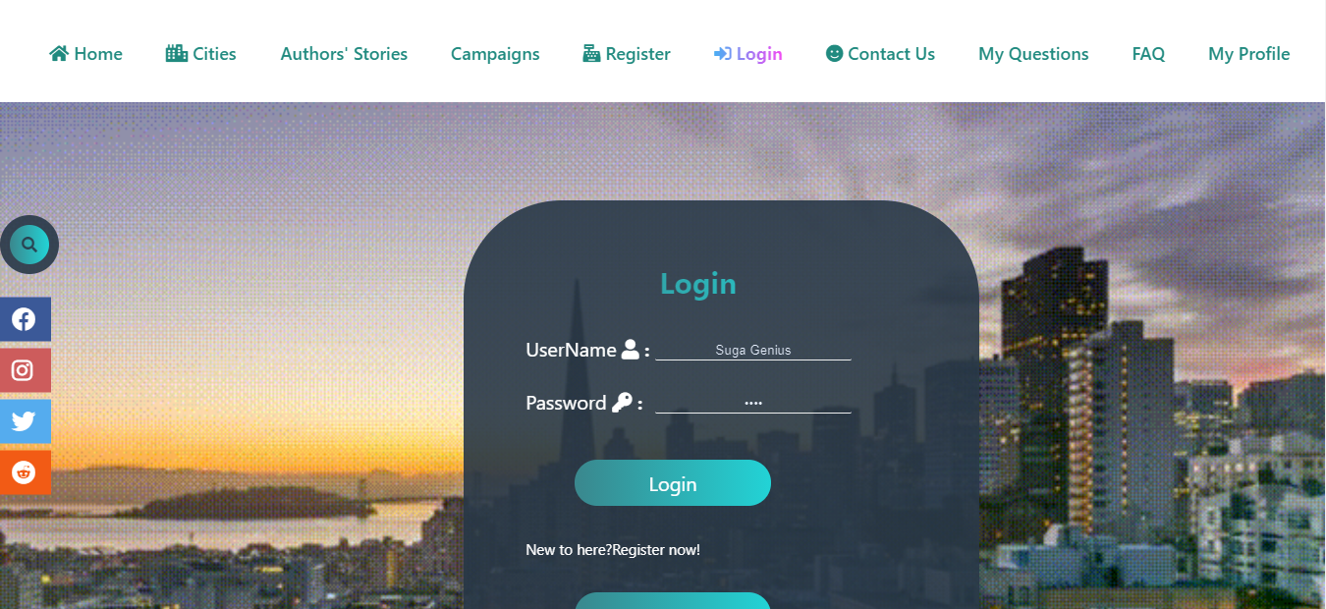

## Coding

UserRegister.php

<?php

include('Connect.php');

if (isset($_REQUEST['enter']))

{

$uname=$_REQUEST['uname'];

$fname=$_REQUEST['fname'];

$lname=$_REQUEST['lname'];

$email=$_REQUEST['email'];

$password=$_REQUEST['password'];

$hashedpassword=md5($password);

$dob=$_REQUEST['date'];

$address=$_REQUEST['address'];

$post=$_REQUEST['post'];

// $pp=$_FILES['pp']['name'];

// $folder="Images/";

// if ($pp)

// {

// $new=$folder.$pp;

// $copy=copy($_FILES['pp']['tmp_name'],$new);

// if (!$copy)

// {

// echo "<script>Something went wrong</script>";

// }

// }

$check="Select * from users where Email='$email'";

$checkrun=mysqli_query($connect, $check);

$count=mysqli_num_rows($checkrun);

if ($count==0)

{

$insert="Insert into users (UserName,FirstName,LastName,Email,Password,DateOfBirth,Address,PostCode) values ('$uname','$fname','$lname','$email','$hashedpassword','$dob','$address','$post')";

$irun=mysqli_query($connect,$insert);

if ($irun)

{

echo "<script>window.alert('Register successful')</script>";

}

else

{

echo "<script>window.alert('Something went wrong')</script>";

echo mysqli_error($connect);

}

}

else

{

echo "<script>window.alert('User already exist')</script>";

}

}

?>

<html>

<head>

<title>UserRegister</title>

<link rel="stylesheet" type="text/css" href="Style.css">

<meta name="viewport" content="width=device-width, intial-scale=1.0">

<script src="https://kit.fontawesome.com/c8fd1d96f9.js" crossorigin="anonymous"></script>

<script src="https://ajax.googleapis.com/ajax/libs/jquery/3.5.1/jquery.min.js"></script>

<!-- <link rel="stylesheet" type="text/css" href="https://stackpath.bootstrapcdn.com/bootstrap/4.5.2/css/bootstrap.min.css"> -->

</head>

<body class="wall">

<div class="head">

<img class="image" src="Images/Title.png">

<input type="checkbox" id="chk">

<label for="chk" class="show-menu-btn">

<i class="fas fa-ellipsis-h"></i>

</label>

<ul class="menu">

<a href="#"><i class="fas fa-home"></i> Home</a>

<a href="UserRegister.php"><span><i class="fas fa-cash-register"></i> Register</span></a>

<a href="UserLogin.php"> <i class="fas fa-sign-in-alt"></i> Login</a>

<a href="#"><i class="fas fa-smile"></i> Contact Us</a>

<label for="chk" class="hide-menu-btn">

<i class="fas fa-times-circle"></i>

</label>

</ul>

</div>

<div class="search-box">

<input class="search-txt" type="text" name="" placeholder="Type to search">

<a class="search-btn" href="#"> <i class="fas fa-search"></i></a>

</div>

<div class="icons">

<ul>

<a href="https://www.facebook.com/"><li class="facebook"><i class="fab fa-facebook"></i></li></a>

<a href="https://www.instagram.com/"><li class="instagram"><i class="fab fa-instagram"></i></li></a>

<a href="https://twitter.com/"><li class="twitter"><i class="fab fa-twitter"></i></li></a>

<a href="https://www.redditinc.com/"><li class="reddit"><i class="fab fa-reddit"></i></li></a>

</ul>

</div>

<form method="post" action="" class="form" >

<table class="table">

<tr>

<th colspan="2">Register Here</th>

</tr>

<tr>

<td> User <i class="fas fa-user"></i> :</td>

<td><input class="input" type="text" name="uname" placeholder="Enter User Name Here" ></td>

</tr>

<tr>

<td>First Name:</td>

<td><input class="input" type="text" name="fname" ></td>

</tr>

<tr>

<td>Last Name:</td>

<td><input class="input" type="text" name="lname"></td>

</tr>

<tr>

<td>Email <i class="fas fa-envelope"></i> :</td>

<td><input class="input" type="text" name="email"></td>

</tr>

<br>

<tr>

<td>Password <i class="fas fa-key"></i> :</td>

<td><input class="input" type="password" name="password"></td>

</tr>

<tr>

<td>Date of Birth <i class="fas fa-calendar-alt"></i> :</td>

<td><input class="input" type="date" name="date" ></td>

</tr>

<tr>

<td>Address <i class="fas fa-house-user"></i> :</td>

<td><input class="input" type="text" name="address"></td>

</tr>

<tr>

<td>Post Code <i class="fas fa-mail-bulk"></i> :</td>

<td><input class="input" type="text" onkeypress="isInputNumber(event)" name="post" placeholder="Only digits allowed"></td>

</tr>

<script type="text/javascript">

function isInputNumber(evt)

{

var ch=String.fromCharCode(evt.which);

if (!(/[0-9]/.test(ch)))

{

evt.preventDefault();

};

}

</script>

<tr>

<td colspan="2"><button type="submit" name="enter" value="Register" class="button">Register</td>

</tr>

<tr>

<td colspan="2"><p>Already have an account? Login Now for free!</p></td>

</tr>

<tr>

<td colspan="2"><a href="UserLogin.php"><button class="button">Login</a></td>

</tr>

</table>

</form>

</body>

</html>

UserLogin.php

<?php

session_start();

include('Connect.php');

if (isset($_REQUEST['login']))

{

$uname=$_REQUEST['txtusername'];

$password=$_REQUEST['txtpassword'];

$hashpassword=md5($password);

$check="Select * from users where UserName='$uname' and Password='$hashpassword'" ;

$checkrun=mysqli_query($connect,$check);

$checkcount=mysqli_num_rows($checkrun);

$userfetch=mysqli_fetch_array($checkrun);

if ($checkcount==1)

{

echo "<script>window.alert('Login Successful')</script>";

$_SESSION['UID']=$userfetch['UserID'];

}

else

{

if (isset($_SESSION['errorcount']))

{

$logincount=$_SESSION['errorcount'];

if ($logincount==1)

{

$_SESSION['errorcount']=2;

echo "<script>window.alert('Login Fail 2nd time')</script>";

echo "<script>window.location='LoginTimer.php'</script>";

}

if ($logincount==2)

{

// echo "<script>window.alert('Login Fail. Your're locked for 10 minutes')</script>";

echo "<script>window.alert('Login Fail.You are locked for 10 minutes')</script>";

echo "<script>window.location='LoginTimer.php'</script>";

}

}

else

{

$_SESSION['errorcount']=1;

echo "<script>window.alert('Login Fail First time')</script>";

echo mysqli_error($connect);

}

}

}

?>

<html>

<head>

<title>Login</title>

<link rel="stylesheet" type="text/css" href="Style.css">

<meta name="viewport" content="width=device-width, intial-scale=1.0">

<script src="https://kit.fontawesome.com/c8fd1d96f9.js" crossorigin="anonymous"></script>

</head>

<body class="wall">

<div class="head">

<h1 class="title">Air Pollution</h1>

<input type="checkbox" id="chk">

<label for="chk" class="show-menu-btn">

<i class="fas fa-ellipsis-h"></i>

</label>

<ul class="menu">

<a href="#"><i class="fas fa-home"></i> Home</a>

<a href="UserRegister.php"><i class="fas fa-cash-register"></i> Register</a>

<a href="UserLogin.php"> <span><i class="fas fa-sign-in-alt"></i> Login</span></a>

<a href="AdminLogout.php"><i class="fas fa-sign-out-alt"></i> Logout</a>

<a href="ContactUs.php"><i class="fas fa-smile"></i> Contact Us</a>

<a href="FaqDisplay.php">FAQ</a>

<label for="chk" class="hide-menu-btn">

<i class="fas fa-times-circle"></i>

</label>

</ul>

</div>

<div class="search-box">

<input class="search-txt" type="text" name="" placeholder="Type to search">

<a class="search-btn" href="#"> <i class="fas fa-search"></i></a>

</div>

<div class="icons">

<ul>

<a href="https://www.facebook.com/"><li class="facebook"><i class="fab fa-facebook"></i></li></a>

<a href="https://www.instagram.com/"><li class="instagram"><i class="fab fa-instagram"></i></li></a>

<a href="https://twitter.com/"><li class="twitter"><i class="fab fa-twitter"></i></li></a>

<a href="https://www.redditinc.com/"><li class="reddit"><i class="fab fa-reddit"></i></li></a>

</ul>

</div>

<form action="" method="post" class="form">

<table class="table">

<tr>

<th colspan="2">Login </th>

</tr>

<tr>

<td>UserName <i class="fas fa-user"> :</td>

<td><input class="input" type="text" name="txtusername"></td>

</tr>

<tr>

<td>Password <i class="fas fa-key"> :</td>

<td><input class="input" type="password" name="txtpassword"></td>

</tr>

<tr>

<td colspan="2"><button type="submit" name="login" value="Login" class="button">Login</td>

</tr>

<tr>

<td colspan="2"><p>New to here?Register now!</p></td>

</tr>

<tr>

<td colspan="2"><a href="UserRegister.php"><button class="button">Register</a></td>

</tr>

</table>

</form>

</body>

</html>

## Testing

**Test Case 1(create Database)**

|  |  |
| --- | --- |
| Test objective | To register user’s information |
| Test Data | User Name: Chris  First Name:Chris  Last Name:Redfield  Email:redfield@gmail.com  Password: Umbrella  Date of Birth:8/9/1992  Address: Amsterdam  PostCode:489 |
| Test Procedure | User register page is operated. Then, all the text boxes in the register form have been filled. Next, the register button below the register form is pressed. |
| Expected Result | All the user information filled into the register form should be inserted into the user table in the database. |
| Actual Result | See images as shown below. |

**Before Testing**:

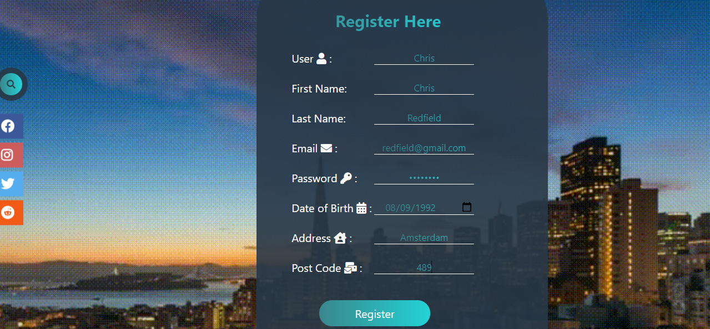

**After Testing:**

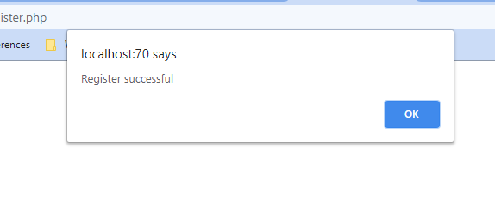

**Test case 2**

|  |  |
| --- | --- |
| Test objective | To show error message when the user inserts the existing email to the user register form. |
| Test Data | User Name: Leon  First Name:Leon  Last Name: Kennedy  Email:redfield@gmail.com  Password:Ada  Date of birth:6/9/1980  Address: Melbourne  PostCode:983 |
| Test Procedure | User register form is filled up with the same email of ‘redfield@gmail.com’ which already exists in the user table in the database. Then the register button is clicked. |
| Expected Result | To show the message alerting the users that they are filling the same email account that is already existed in the database. |
| Actual Result | As shown below. |

**Before Testing**

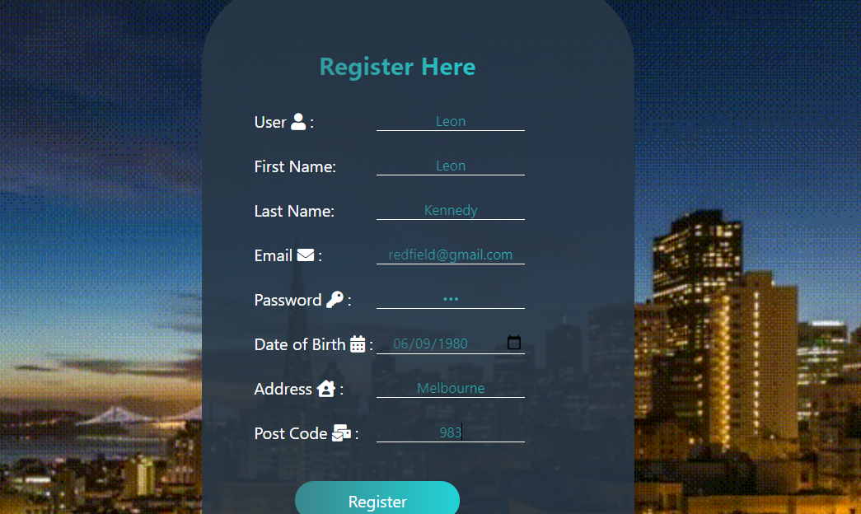

**After testing**

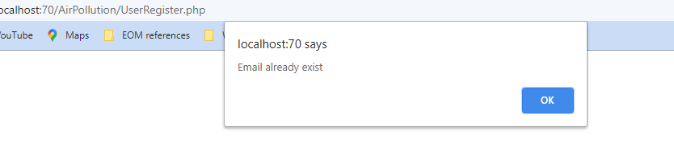

**Test Case 3**

|  |  |
| --- | --- |
| Test objective | Using hashing as security measure |
| Test Data | User Name: Hermione  First Name:Hermione  Last Name: Granger  Email:hermione@gmail.com  Password:Gryffindor  Date of birth:8/17/2003  Address: London  PostCode:347 |
| Test Procedure | User register form is filled with the information as shown above. |
| Expected Result | The password filled by user is ‘Gryffindor’ but the password which is the hashed version of the original one will be saved into the data base. |
| Actual Result | As shown below. |

**Before testing**

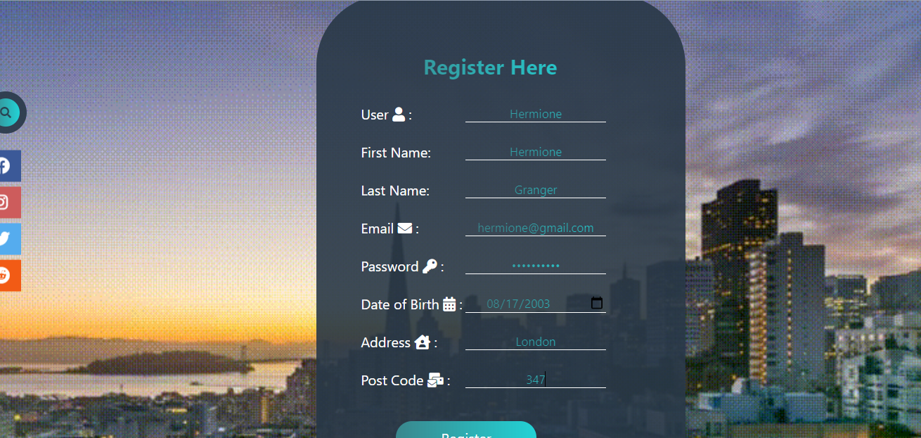

**After Testing**



**Test Case 4**

|  |  |
| --- | --- |
| Test objective | Showing message when one of the information is left to fill in the user register form |
| Test Data | User Name: Bella  First Name: Bellatrix  Last Name: Lestrange  Email:  Password:*********  DateOfBirth:09/02/1976  Address: Diagon Alley  PostCode:638 |
| Test Procedure | All the information in the user register is filled except the email. Then the register button is pressed. |
| Expected Result | To show message alerting users to fill the required text box. |
| Actual Result | As shown below. |

**Before testing**

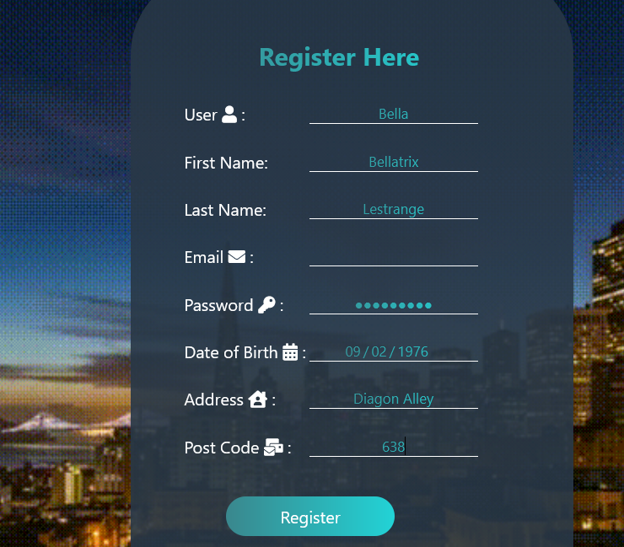

**After testing**

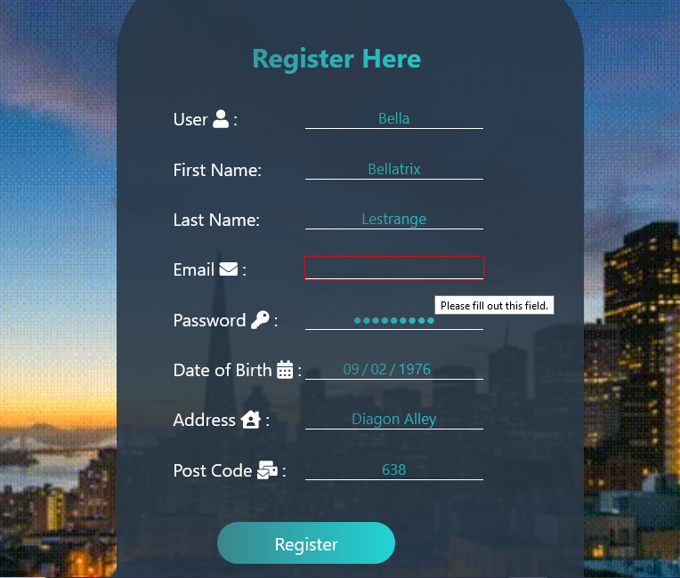

**Test Case 5(create Database)**

|  |  |
| --- | --- |
| Test objective | To show error message after failing first time in Login |
| Test Data | User Name: Allison  Password: Allison |
| Test Procedure | The login form is filled up with the wrong username and password which is differ from those that exist in the database. And then, the login button is clicked. |
| Expected Result | The message saying “Login fail first time” must appear after clicking the login button. |
| Actual Result | As shown below. |

**Before testing**

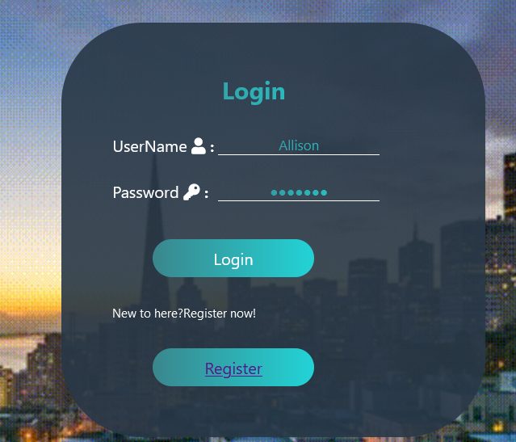

**After testing**

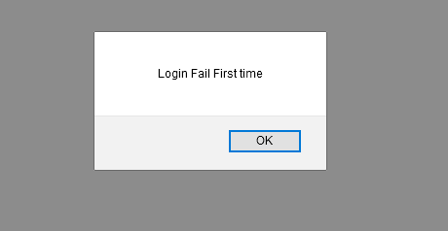

**Test Case 6(create Database)**

|  |  |
| --- | --- |
| Test objective | Locking up users for 10 minutes straight after failing 3 times of login |
| Test Data | User Name: Allison  Password: Allison |
| Test Procedure | The login form is filled with wrong user name and password just like in the test case 5 shown above for 3 times. |
| Expected Result | The login fail message must appear on first and second attempts of failing and then lock user for ten minutes of login after third attempt of failing. |
| Actual Result | As shown below. |

**Before testing**



**After Testing**



**Before Testing**



**After testing**

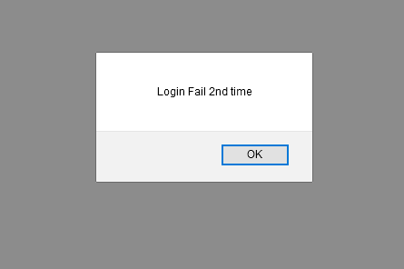

**Before testing**



**After Testing**

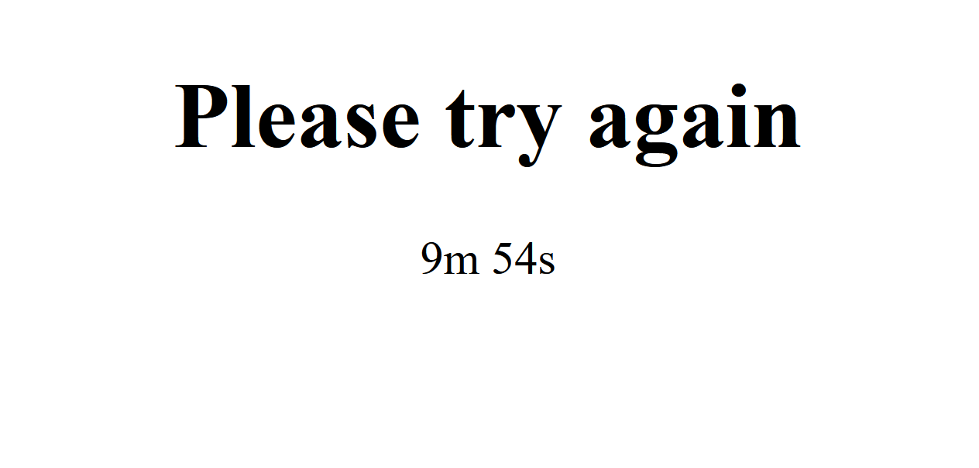

**Task 3**

# Task – 3

## Analysis

In this task, the users which are called admins in this Air Pollution website need to be able to access into their account after they have logged in. Afterwards, the Contact us page where the customers also known as users in this website can ask the questions about air pollution should be created. Then, the FAQ page will be created from the admin side and those FAQs should be displayed on the users’ side.

## Assumptions

Firstly, both the login page and register page for admins will be built. Then, the FAQ page will be created from the admin’s side where admins write frequently asked answers and questions about air pollution to provide their customers with a bunch of FAQs. But for the security measures, the FAQ page will only operate after the admins logged in.

Afterwards, the Contact Us page will be created on the users’ side where users can ask questions about air pollution after logging in first. When they click on the submit button after filling in the question text box, they will be directed to FAQ page where the FAQs that are provided by admins will be displayed so that users can seek their wanted questions and answer before asking the admins first. If there is no answers and questions that meet their needs, they can confirm to send their question to admins by clicking on the “Ask anyway” button.

Next on the admins’ side, the “Asked questions” page will be created where there will be the user’s names and their asked questions will be shown. In this page, the admins can answer to those questions by clicking on to “Reply now” button and then write the reply on the reply page which will be created after the Asked questions page. Then, on the user’s side, “My questions” page will be made where the users can view their asked questions and they can check out the answers for those questions which are replied by admins. And if those questions hasn’t been replied yet, the message that will inform users that their questions haven’t been replied yet will appear.

## Screen Design

**AdminRegister.php**

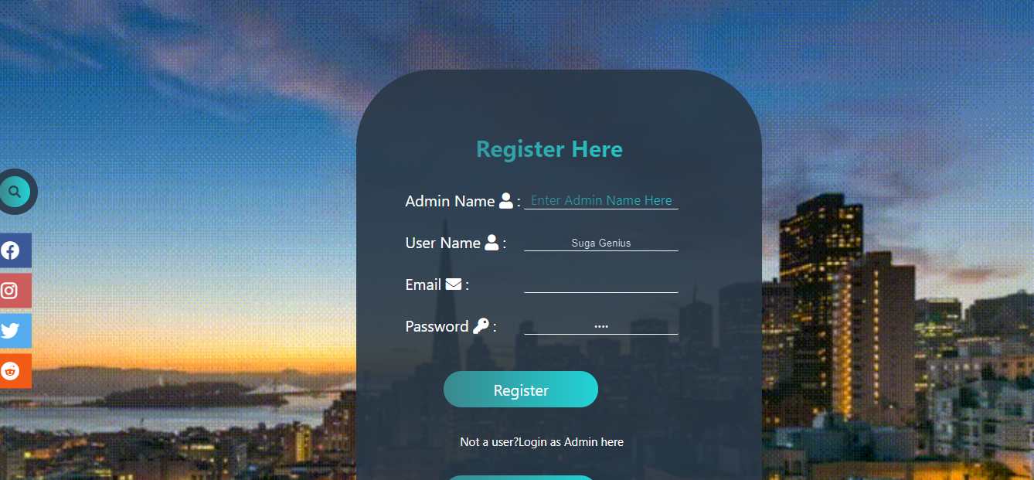

**AdminLogin.php**

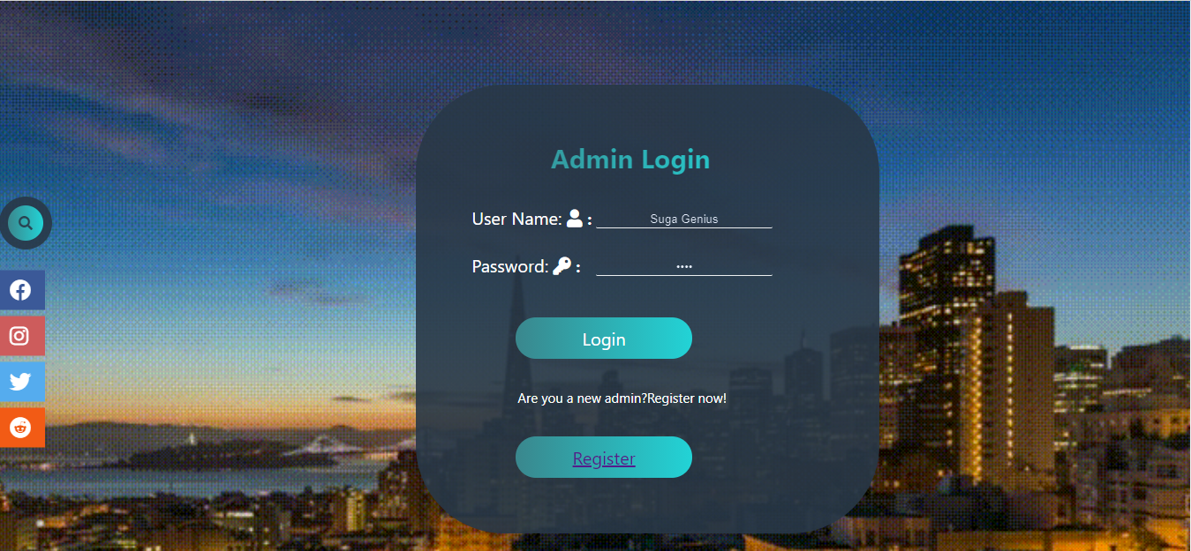

**Faq.php**

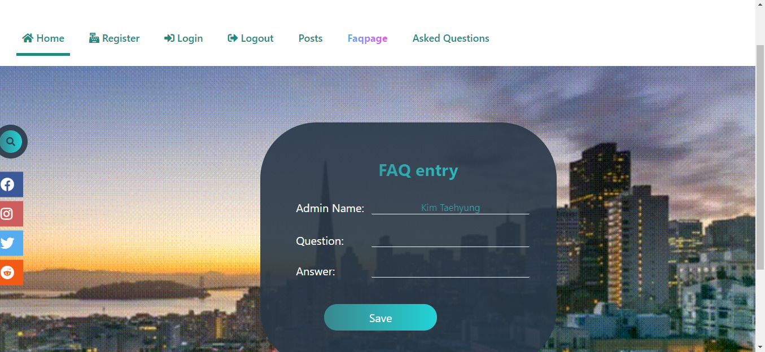

**Questiondisplay.php**

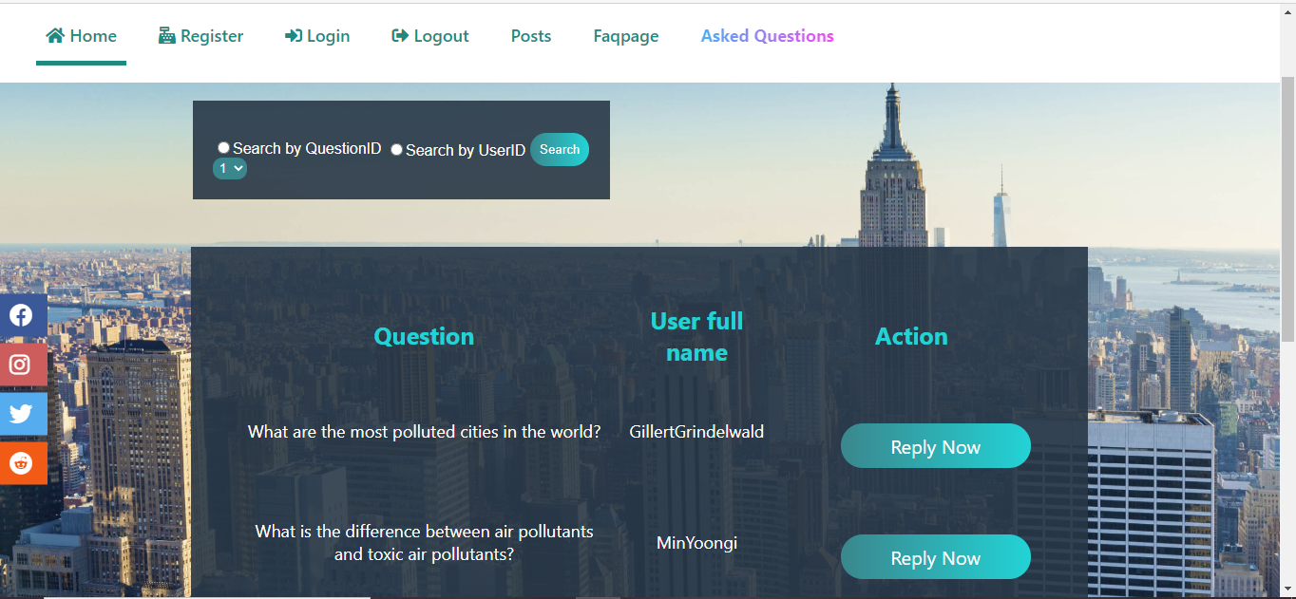

**ContactUs.php**

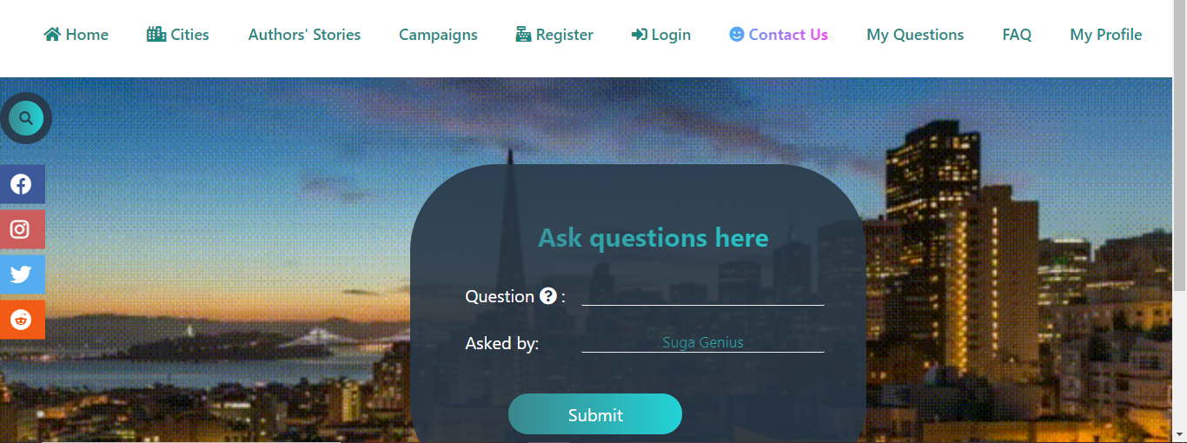

**MyQuestions.php**

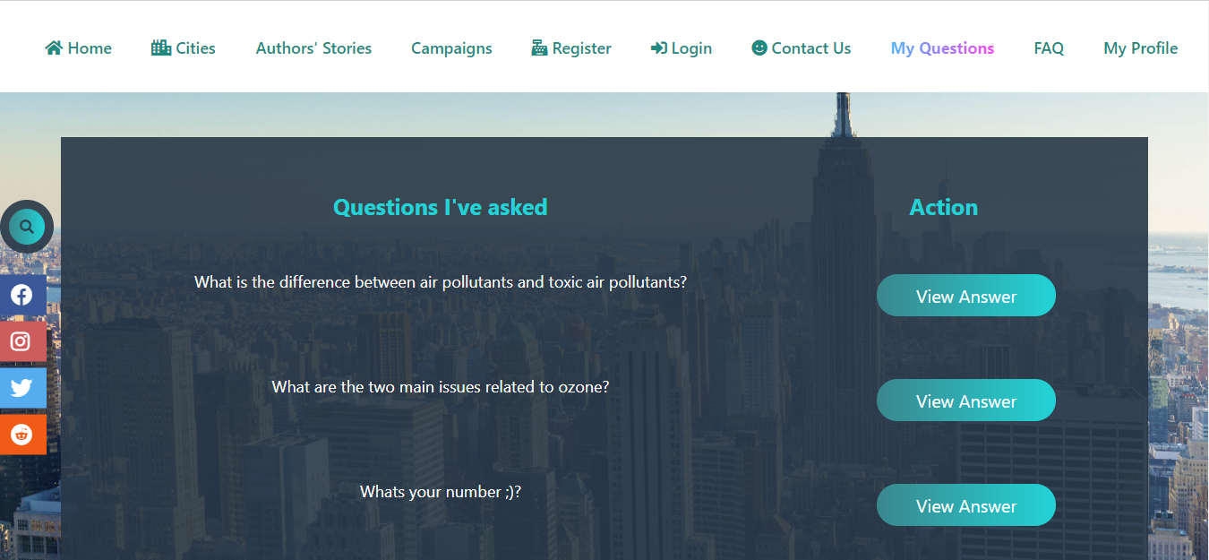

**FaqDisplay.php**

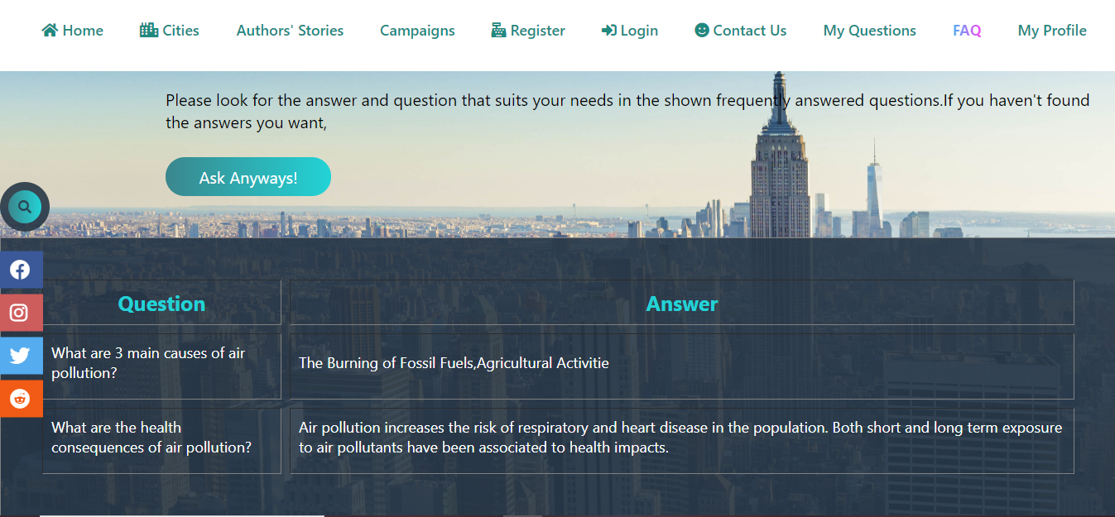

## Coding

**AdminRegister.php**

<?php

include('Connect.php');

if (isset($_REQUEST['enter']))

{

$name=$_REQUEST['aname'];

$uname=$_REQUEST['uname'];

$email=$_REQUEST['email'];

$password=$_REQUEST['password'];

$insert="Insert into admin(AdminName,UserName,Email,Password) values ('$name','$uname','$email','$password')";

$irun=mysqli_query($connect,$insert);

if ($irun)

{

echo "<script>window.alert('Register Successful')</script>";

}

else

{

echo "<script>window.alert('Something went wrong')</script>";

}

}

?>

<html>

<head>

<title>AdminRegister</title>

<link rel="stylesheet" type="text/css" href="Style.css">

<meta name="viewport" content="width=device-width, intial-scale=1.0">

<script src="https://kit.fontawesome.com/c8fd1d96f9.js" crossorigin="anonymous"></script>

</head>

<body class="wall">

<div class="head">

<h1 class="title">Air Pollution</h1>

<input type="checkbox" id="chk">

<label for="chk" class="show-menu-btn">

<i class="fas fa-ellipsis-h"></i>

</label>

<ul class="menu">

<a href="#"><i class="fas fa-home"></i> Home</a>

<a href="AdminRegister.php"><span><i class="fas fa-cash-register"></i> Register</span></a>

<a href="AdminLogin.php"> <i class="fas fa-sign-in-alt"></i> Login</a>

<a href="AdminLogout.php"><i class="fas fa-sign-out-alt"></i> Logout</a>

<a href="Faq.php">Faqpage</a>

<a href="QuestionDisplay.php">Asked Questions</a>

<label for="chk" class="hide-menu-btn">

<i class="fas fa-times-circle"></i>

</label>

</ul>

</div>

<div class="search-box">

<input class="search-txt" type="text" name="" placeholder="Type to search">

<a class="search-btn" href="#"> <i class="fas fa-search"></i></a>

</div>

<div class="icons">

<ul>

<a href="https://www.facebook.com/"><li class="facebook"><i class="fab fa-facebook"></i></li></a>

<a href="https://www.instagram.com/"><li class="instagram"><i class="fab fa-instagram"></i></li></a>

<a href="https://twitter.com/"><li class="twitter"><i class="fab fa-twitter"></i></li></a>

<a href="https://www.redditinc.com/"><li class="reddit"><i class="fab fa-reddit"></i></li></a>

</ul>

</div>

<form method="post" action="" class="form" >

<table class="table">

<tr>

<th colspan="2">Register Here</th>

</tr>

<tr>

<td>Admin Name <i class="fas fa-user"></i> :</td>

<td><input class="input" type="text" name="aname" placeholder="Enter Admin Name Here" ></td>

</tr>

<tr>

<td>User Name <i class="fas fa-user"></i> :</td>

<td><input class="input" type="text" name="uname" placeholder="Enter User Name Here" ></td>

</tr>

<tr>

<td>Email <i class="fas fa-envelope"></i> :</td>

<td><input class="input" type="text" name="email"></td>

</tr>

<br>

<tr>

<td>Password <i class="fas fa-key"></i> :</td>

<td><input class="input" type="password" name="password"></td>

</tr>

<tr>

<td colspan="2"><button type="submit" name="enter" value="Register" class="button">Register</td>

</tr>

<tr>

<td colspan="2"><p align="center">Not a user?Login as Admin here</p></td>

</tr>

<tr>

<td colspan="2"><a href="AdminLogin.php"><button class="button">Login</a></td>

</tr>

</table>

</form>

</body>

</html>

**AdminLogin.php**

<?php

session_start();

include('Connect.php');

if (isset($_REQUEST['login']))

{

$uname=$_REQUEST['txtusername'];

$password=$_REQUEST['txtpassword'];

$aselect="Select * from admin where UserName='$uname' and Password='$password'";

$aselectrun=mysqli_query($connect,$aselect);

$acount=mysqli_num_rows($aselectrun);

$afetch=mysqli_fetch_array($aselectrun);

if ($acount>0)

{

echo "<script>window.alert('Login Successful')</script>";

$_SESSION['AID']=$afetch['AdminID'];

}

else

{

echo "<script>window.alert('Something went wrong')</script>";

}

}

?>

<html>

<head>

<title>Admin Login</title>

<link rel="stylesheet" type="text/css" href="Style.css">

<meta name="viewport" content="width=device-width, intial-scale=1.0">

<script src="https://kit.fontawesome.com/c8fd1d96f9.js" crossorigin="anonymous"></script>

</head>

<body class="wall">

<div class="head">

<h1 class="title">Air Pollution</h1>

<input type="checkbox" id="chk">

<label for="chk" class="show-menu-btn">

<i class="fas fa-ellipsis-h"></i>

</label>

<ul class="menu">

<a href="#"><i class="fas fa-home"></i> Home</a>

<a href="AdminRegister.php"><i class="fas fa-cash-register"></i> Register</a>

<a href="#"><span> <i class="fas fa-sign-in-alt"></i> Login</span></a>

<a href="AdminLogout.php"><i class="fas fa-sign-out-alt"></i> Logout</a>

<a href="Faq.php">Faqpage</a>

<a href="QuestionDisplay.php">Asked Questions</a>

<label for="chk" class="hide-menu-btn">

<i class="fas fa-times-circle"></i>

</label>

</ul>

</div>

<div class="search-box">

<input class="search-txt" type="text" name="" placeholder="Type to search">

<a class="search-btn" href="#"> <i class="fas fa-search"></i></a>

</div>

<div class="icons">

<ul>

<a href="https://www.facebook.com/"><li class="facebook"><i class="fab fa-facebook"></i></li></a>

<a href="https://www.instagram.com/"><li class="instagram"><i class="fab fa-instagram"></i></li></a>

<a href="https://twitter.com/"><li class="twitter"><i class="fab fa-twitter"></i></li></a>

<a href="https://www.redditinc.com/"><li class="reddit"><i class="fab fa-reddit"></i></li></a>

</ul>

</div>

<form action="" method="post" class="form">

<table class="table">

<tr>

<th colspan="2">Admin Login </th>

</tr>

<tr>

<td>UserName: <i class="fas fa-user"> :</td>

<td><input class="input" type="text" name="txtusername"></td>

</tr>

<tr>

<td>Password: <i class="fas fa-key"> :</td>

<td><input class="input" type="password" name="txtpassword"></td>

</tr>

<tr>

<td colspan="2"><button type="submit" name="login" value="Login" class="button">Login</td>

</tr>

<tr>

<td colspan="2"><p align="center">Are you a new admin?Register now!</p></td>

</tr>

<tr>

<td colspan="2"><a href="AdminRegister.php"><button class="button">Register</a></td>

</tr>

</table>

</form>

</body>

</html>

**Faq.php**

<?php

session_start();

include('Connect.php');

if (!isset($_SESSION['AID']))

{

echo "<script>window.alert('You have no authorization!Login as admin first')</script>";

echo "<script>window.location='AdminLogin.php'</script>";

}

$AdminID=$_SESSION['AID'];

$aselect="Select * from admin where AdminID='$AdminID'";

$aselrun=mysqli_query($connect,$aselect);

$afetch=mysqli_fetch_array($aselrun);

$aname=$afetch['AdminName'];

if (isset($_REQUEST['btnsave']))

{

$aid=$_REQUEST['aid'];

$question=$_REQUEST['question'];

$answer=$_REQUEST['answer'];

$finsert="Insert into faq (AdminID,Question,Answer) values('$aid','$question','$answer')";

$frun=mysqli_query($connect,$finsert);

if ($frun)

{

echo "<script>window.alert('Question saved')</script>";

}

else

{

echo "<script>window.alert('Something went wrong')</script>";

}

}

?>

<html>

<head>

<title>FAQ</title>

<link rel="stylesheet" type="text/css" href="Style.css">

<meta name="viewport" content="width=device-width, intial-scale=1.0">

<script src="https://kit.fontawesome.com/c8fd1d96f9.js" crossorigin="anonymous"></script>

</head>

<body class="wall">

<div class="head">

<h1 class="title">Air Pollution</h1>

<input type="checkbox" id="chk">

<label for="chk" class="show-menu-btn">

<i class="fas fa-ellipsis-h"></i>

</label>

<ul class="menu">

<a href="#"><i class="fas fa-home"></i> Home</a>

<a href="AdminRegister.php"><i class="fas fa-cash-register"></i> Register</a>

<a href="AdminLogin.php"> <i class="fas fa-sign-in-alt"></i> Login</a>

<a href="AdminLogout.php"><i class="fas fa-sign-out-alt"></i> Logout</a>

<a href="Faq.php"><span>Faqpage</span></a>

<a href="QuestionDisplay.php">Asked Questions</a>

<label for="chk" class="hide-menu-btn">

<i class="fas fa-times-circle"></i>

</label>

</ul>

</div>

<div class="search-box">

<input class="search-txt" type="text" name="" placeholder="Type to search">

<a class="search-btn" href="#"> <i class="fas fa-search"></i></a>

</div>

<div class="icons">

<ul>

<a href="https://www.facebook.com/"><li class="facebook"><i class="fab fa-facebook"></i></li></a>

<a href="https://www.instagram.com/"><li class="instagram"><i class="fab fa-instagram"></i></li></a>

<a href="https://twitter.com/"><li class="twitter"><i class="fab fa-twitter"></i></li></a>

<a href="https://www.redditinc.com/"><li class="reddit"><i class="fab fa-reddit"></i></li></a>

</ul>

</div>

<form method="post" action="" class="form">

<table class="table">

<tr>

<th colspan="2">FAQ entry</th>

</tr>

<tr>

<td>Admin Name:</td>

<td><input type="text" name="aname" value="<?php echo $aname ?>"readonly class="qust"></td>

</tr>

<tr>

<td><input type="hidden" name="aid" value="<?php echo $AdminID ?>" class="qust"></td>

</tr>

<tr>

<td>Question:</td>

<td><input type="text" name="question"class="qust" ></td>

</tr>

<tr>

<td>Answer:</td>

<td><input type="text" name="answer" class="qust"></td>

</tr>

<tr>

<td><input type="submit" name="btnsave" value="Save" class="button"></td>

</tr>

</table>

</form>

</body>

</html>

**QuestionDisplay.php**

<?php

include('Connect.php');

$Select="Select * from users u,contactfaq c where u.UserID=c.UserID";

$selrun=mysqli_query($connect,$Select);

$qcount=mysqli_num_rows($selrun);

if (isset($_REQUEST['btnsearch']))

{

$searchtype=$_REQUEST['rdosearch'];

if ($searchtype=='QID')

{

$QuestionID=$_REQUEST['selqid'];

$Select="Select * from users u, contactfaq c where u.UserID=c.UserID and c.QuestionID='$QuestionID'";

$selrun=mysqli_query($connect,$Select);

$qcount=mysqli_num_rows($selrun);

}

}

?>

<html>

<head>

<title>Asked Questions</title>

<link rel="stylesheet" type="text/css" href="Style.css">

<meta name="viewport" content="width=device-width, intial-scale=1.0">

<script src="https://kit.fontawesome.com/c8fd1d96f9.js" crossorigin="anonymous"></script>

<script src="https://ajax.googleapis.com/ajax/libs/jquery/3.5.1/jquery.min.js"></script>

</head>

<body class="newyork">

<div class="head">

<h1 class="title">Air Pollution</h1>

<input type="checkbox" id="chk">

<label for="chk" class="show-menu-btn">

<i class="fas fa-ellipsis-h"></i>

</label>

<ul class="menu">

<a href="#"><i class="fas fa-home"></i> Home</a>

<a href="AdminRegister.php"><i class="fas fa-cash-register"></i> Register</a>

<a href="AdminLogin.php"> <i class="fas fa-sign-in-alt"></i> Login</a>

<a href="AdminLogout.php"><i class="fas fa-sign-out-alt"></i> Logout</a>

<a href="Faq.php">Faqpage</a>

<a href="QuestionDisplay.php"><span>Asked Questions</span></a>

<label for="chk" class="hide-menu-btn">

<i class="fas fa-times-circle"></i>

</label>

</ul>

</div>

<form action="" method="post">

<table class="tbl">

<tr>

<td class="question">

<input type="radio" name="rdosearch" value="QID">Search by QuestionID

<br>

<select name="selqid" class="row">

<?php

$Qselect="Select * from contactfaq ";

$Qselrun=mysqli_query($connect,$Qselect);

$Qcount=mysqli_num_rows($Qselrun);

for ($i=0; $i <$Qcount ; $i++)

{

$Qfetch=mysqli_fetch_array($Qselrun);

$Qid=$Qfetch['QuestionID'];

echo "<option value='$Qid'>$Qid</option>";

}

?>

</select>

</td>

<td class="user">

<input type="radio" name="rdosearch" value="UID">Search by UserID

</td>

<td>

<input type="submit" name="btnsearch" value="Search" class="srch">

</td>

</tr>

</table>

</form>

<div class="icons">

<ul>

<a href="https://www.facebook.com/"><li class="facebook"><i class="fab fa-facebook"></i></li></a>

<a href="https://www.instagram.com/"><li class="instagram"><i class="fab fa-instagram"></i></li></a>

<a href="https://twitter.com/"><li class="twitter"><i class="fab fa-twitter"></i></li></a>

<a href="https://www.redditinc.com/"><li class="reddit"><i class="fab fa-reddit"></i></li></a>

</ul>

</div>

<table width="70%" align="center" cellspacing="10" cellpadding="10" class="faqtable">

<tr class="tbltitle">

<th>Question</th>

<th>User full name</th>

<th>Action</th>

</tr>

<?php

for ($i=0; $i <$qcount ; $i++)

{

$qfetch=mysqli_fetch_array($selrun);

$question=$qfetch['Question'];

$fname=$qfetch['FirstName'];

$lname=$qfetch['LastName'];

$qid=$qfetch['QuestionID'];

?>

<tr align="center">

<td><?php echo $question ?></td>

<td><?php echo $fname."".$lname ?></td>

<td><a href="Reply.php?QID=<?php echo $qid ?>"><input type="button" class="button" value="Reply Now"></a></td>

</tr>

<?php

}

?>

</table>

</body>

</html>

**ContactUs.php**

<?php

session_start();

include('Connect.php');

if (!isset($_SESSION['UID']))

{

echo "<script>window.alert('You have no permission!Login first')</script>";

echo "<script>window.location='UserLogin.php'</script>";

}

$UserID=$_SESSION['UID'];

$uselect="Select * from users where UserID='$UserID'";

$uselrun=mysqli_query($connect,$uselect);

$ufetch=mysqli_fetch_array($uselrun);

$uname=$ufetch['UserName'];

$uid=$ufetch['UserID'];

?>

<html>

<head>

<title>Contact Us</title>

<link rel="stylesheet" type="text/css" href="Style.css">

<meta name="viewport" content="width=device-width, intial-scale=1.0">

<script src="https://kit.fontawesome.com/c8fd1d96f9.js" crossorigin="anonymous"></script>

</head>

<body class="wall">

<div class="head">

<h1 class="title">Air Pollution</h1>

<input type="checkbox" id="chk">

<label for="chk" class="show-menu-btn">

<i class="fas fa-ellipsis-h"></i>

</label>

<ul class="menu">

<a href="#"><i class="fas fa-home"></i> Home</a>

<a href="UserRegister.php"><i class="fas fa-cash-register"></i> Register</a>

<a href="UserLogin.php"> <i class="fas fa-sign-in-alt"></i> Login</a>

<a href="AdminLogout.php"><i class="fas fa-sign-out-alt"></i> Logout</a>

<a href="ContactUs.php"><span><i class="fas fa-smile"></i> Contact Us</span></a>

<a href="MyQuestions.php">My Questions</a>

<a href="FaqDisplay.php">FAQ</a>

<a href="viewprofile.php">My Profile</a>

<label for="chk" class="hide-menu-btn">

<i class="fas fa-times-circle"></i>

</label>

</ul>

</div>

<div class="search-box">

<input class="search-txt" type="text" name="" placeholder="Type to search">

<a class="search-btn" href="#"> <i class="fas fa-search"></i></a>

</div>

<div class="icons">

<ul>

<a href="https://www.facebook.com/"><li class="facebook"><i class="fab fa-facebook"></i></li></a>

<a href="https://www.instagram.com/"><li class="instagram"><i class="fab fa-instagram"></i></li></a>

<a href="https://twitter.com/"><li class="twitter"><i class="fab fa-twitter"></i></li></a>

<a href="https://www.redditinc.com/"><li class="reddit"><i class="fab fa-reddit"></i></li></a>

</ul>

</div>

<form method="post" action="FaqDisplay.php" class="form" >

<table class="table" width="40%">

<tr>

<th colspan="2">Ask questions here</th>

</tr>

<tr>

<td>Question <i class="fas fa-question-circle"></i> :</td>

<td><input type="text" name="question" class="qust"></td>

</tr>

<tr>

<td>Asked by:</td>

<td><input type="text" name="uname" value="<?php echo $uname ?>" readonly class="qust"></td>

</tr>

<tr>

<td><input type="submit" name="submit" value="Submit" class="button"></td>

</tr>

</table>

<input type="hidden" name="uid" value="<?php echo $uid ?>">

</form>

</body>

</html>

**MyQuestions.php**

<?php

include('Connect.php');

session_start();

if (isset($_SESSION['UID']))

{

$userid=$_SESSION['UID'];

$qselect="Select * from contactfaq c, users u where c.UserID=u.UserID and u.UserID='$userid'";

$qrun=mysqli_query($connect,$qselect);

$count=mysqli_num_rows($qrun);

}

?>

<html>

<head>

<title>My Questions</title>

<link rel="stylesheet" type="text/css" href="Style.css">

<meta name="viewport" content="width=device-width, intial-scale=1.0">

<script src="https://kit.fontawesome.com/c8fd1d96f9.js" crossorigin="anonymous"></script>

<script src="https://ajax.googleapis.com/ajax/libs/jquery/3.5.1/jquery.min.js"></script>

</head>

<body class="newyork">

<div class="head">

<h1 class="title">Air Pollution</h1>

<input type="checkbox" id="chk">

<label for="chk" class="show-menu-btn">

<i class="fas fa-ellipsis-h"></i>

</label>

<ul class="menu">

<a href="#"><i class="fas fa-home"></i> Home</a>

<a href="UserRegister.php"><i class="fas fa-cash-register"></i> Register</a>

<a href="UserLogin.php"> <i class="fas fa-sign-in-alt"></i> Login</a>

<a href="AdminLogout.php"><i class="fas fa-sign-out-alt"></i> Logout</a>

<a href="ContactUs.php"><i class="fas fa-smile"></i> Contact Us</a>

<a href="MyQuestions.php"><span>My Questions</span></a>

<a href="FaqDisplay.php">FAQ</a>

<a href="viewprofile.php">My Profile</a>

<label for="chk" class="hide-menu-btn">

<i class="fas fa-times-circle"></i>

</label>

</ul>

</div>

<div class="search-box">

<input class="search-txt" type="text" name="" placeholder="Type to search">

<a class="search-btn" href="#"> <i class="fas fa-search"></i></a>

</div>

<div class="icons">

<ul>

<a href="https://www.facebook.com/"><li class="facebook"><i class="fab fa-facebook"></i></li></a>

<a href="https://www.instagram.com/"><li class="instagram"><i class="fab fa-instagram"></i></li></a>

<a href="https://twitter.com/"><li class="twitter"><i class="fab fa-twitter"></i></li></a>

<a href="https://www.redditinc.com/"><li class="reddit"><i class="fab fa-reddit"></i></li></a>

</ul>

</div>

<table align="center" class="faqtable" width="90%" align="center" cellspacing="10" cellpadding="10">

<tr align="center">

<th>Questions I've asked</th>

<th>Action</th>

</tr>

<?php

for ($i=0; $i <$count ; $i++)

{

$qfetch=mysqli_fetch_array($qrun);

$question=$qfetch['Question'];

$qid=$qfetch['QuestionID'];

?>

<tr align="center">

<td><?php echo $question ?></td>

<td><a href="Answer.php?QID=<?php echo $qid ?>"><input type="button" value="View Answer" class="button"></a></td>

</tr>

<?php

}

?>

</table>

</body>

</html>

**FaqDisplay.php**

<?php

include('Connect.php');

$qselect="Select * from faq";

$qselrun=mysqli_query($connect,$qselect);

$qcount=mysqli_num_rows($qselrun);

if (isset($_REQUEST['submit']))

{

$ques=$_REQUEST['question'];

$uid=$_REQUEST['uid'];

}

if (isset($_REQUEST['askconfirm']))

{

$question=$_REQUEST['txtques'];

$UserID=$_REQUEST['UserID']; //or $UserID=$_SESSION['UID'];

$qinsert="Insert into contactfaq (Question,UserID) values ('$question','$UserID')";

$qrun=mysqli_query($connect,$qinsert);

if ($qrun)

{

echo "<script>window.alert('Question is asked')</script>";

echo "<script>window.location='ContactUs.php'</script>";

}

else

{

echo "<script>window.alert('Something went wrong')</script>";

}

}

?>

<html>

<head>

<title>FaqDisplay</title>

<link rel="stylesheet" type="text/css" href="Style.css">

<meta name="viewport" content="width=device-width, intial-scale=1.0">

<script src="https://kit.fontawesome.com/c8fd1d96f9.js" crossorigin="anonymous"></script>

</head>

<body class="newyork">

<div class="head">

<h1 class="title">Air Pollution</h1>

<input type="checkbox" id="chk">

<label for="chk" class="show-menu-btn">

<i class="fas fa-ellipsis-h"></i>

</label>

<ul class="menu">

<a href="#"><i class="fas fa-home"></i> Home</a>

<a href="UserRegister.php"><i class="fas fa-cash-register"></i> Register</a>

<a href="UserLogin.php"> <i class="fas fa-sign-in-alt"></i> Login</a>

<a href="AdminLogout.php"><i class="fas fa-sign-out-alt"></i> Logout</a>

<a href="ContactUs.php"><i class="fas fa-smile"></i> Contact Us</a>

<a href="MyQuestions.php">My Questions</a>

<a href="FaqDisplay.php"><span>FAQ</span></a>

<a href="viewprofile.php">My Profile</a>

<label for="chk" class="hide-menu-btn">

<i class="fas fa-times-circle"></i>

</label>

</ul>

</div>

<div class="search-box">

<input class="search-txt" type="text" name="" placeholder="Type to search">

<a class="search-btn" href="#"> <i class="fas fa-search"></i></a>

</div>

<div class="icons">

<ul>

<a href="https://www.facebook.com/"><li class="facebook"><i class="fab fa-facebook"></i></li></a>

<a href="https://www.instagram.com/"><li class="instagram"><i class="fab fa-instagram"></i></li></a>

<a href="https://twitter.com/"><li class="twitter"><i class="fab fa-twitter"></i></li></a>

<a href="https://www.redditinc.com/"><li class="reddit"><i class="fab fa-reddit"></i></li></a>

</ul>

</div>

<table class="faqtable" cellspacing="10" cellpadding="10" border="1">

<tr class="tbltitle">

<th>Question</th>

<th>Answer</th>

</tr>

<?php

for ($i=0; $i <$qcount ; $i++)

{

$qfetch=mysqli_fetch_array($qselrun);

$question=$qfetch['Question'];

$Answer=$qfetch['Answer'];

?>

<tr align="left">

<td><?php echo $question ?></td>

<td><?php echo $Answer ?></td>

</tr>

<?php

}

?>

<form action="" method="post">

<input type="hidden" name="txtques" value="<?php echo $ques ?>" >

<input type="hidden" name="UserID" value="<?php echo $uid ?>">

<div class="bruh"><p class="duh">Please look for the answer and question that suits your needs in the shown frequently answered questions.If you haven't found the answers you want, </p> <input type="submit" name="askconfirm" value="Ask Anyways!" class="ask"></div>

</form>

</table>

</body>

</html>

## Testing

**Test Case 1**

|  |  |
| --- | --- |
| Test objective | To register admin’s information |
| Test Data | Admin Name: Kim Taehyung  User Name: Vante  Email: [taetae@gmail.com](mailto:taetae@gmail.com)  Password:***** |
| Test Procedure | Admin register page is operated. All the admin information are filled in the register form. Then, click the Register button. |
| Expected Result | All the admin information filled in this register form must be inserted into the admin table in the database. |
| Actual Result | As shown below. |

Before Testing:

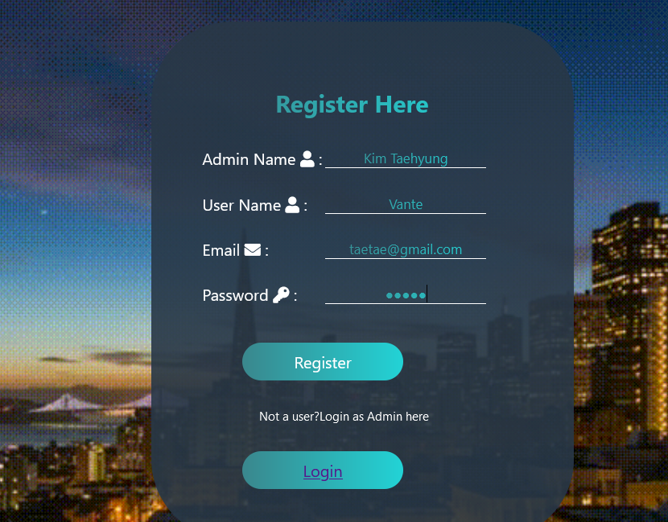

After Testing:

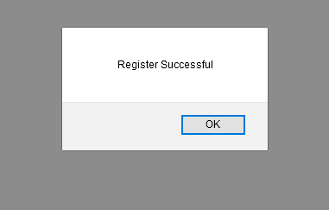



**Test Case 2**

|  |  |
| --- | --- |
| Test objective | To show “Login Successful” message if the user login with the correct admin information |
| Test Data | User Name: Vante  Password:Vante |
| Test Procedure | The login form is filled with admin’s information that exists in the admin table in the database. Then the login button is pressed to activate the login procedure. |
| Expected Result | An alert box saying “Login successful” must be shown to remind the admins that they have Logined successfully. |
| Actual Result | As shown below. |

Before testing:

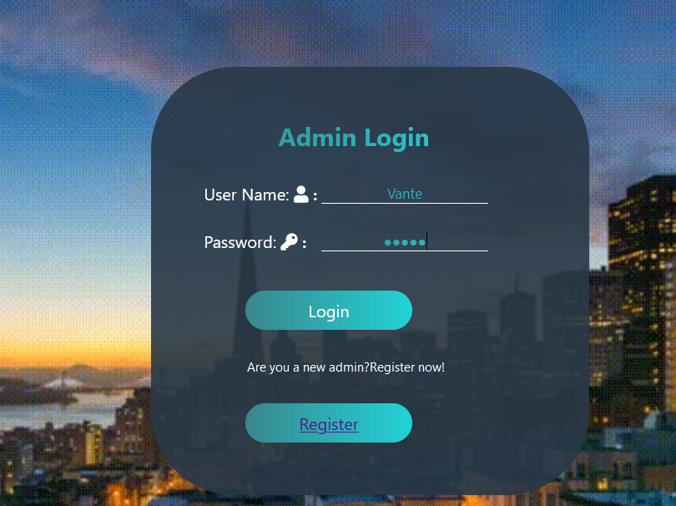

After testing:

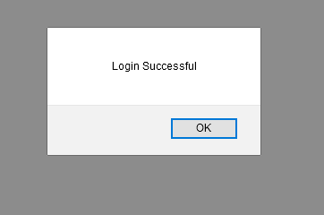

**Test case 3**

|  |  |
| --- | --- |
| Test objective | To show the error message after failing the login process. |
| Test Data | User Name: Ariana  Password: **** |
| Test Procedure | The login form is filled with the user name and password which are differ from admin’s information that exist in the database. |
| Expected Result | The alert box saying “Something went wrong” must appear to inform the admins that they failed the login procedure. |
| Actual Result | As shown below. |

**Before testing**

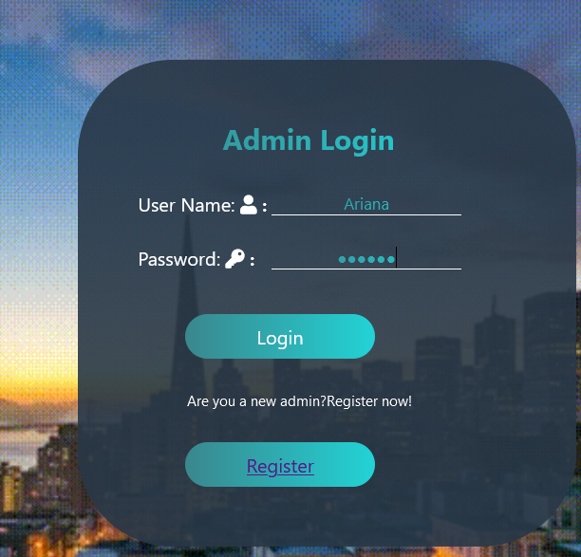

**After testing**

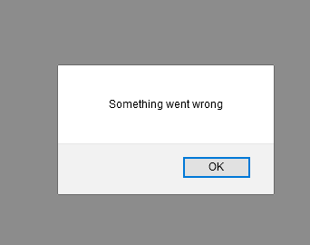

**Test case 4**

|  |  |
| --- | --- |
| Test objective | To show error message when the admin enters the Faq page without logging in first. |
| Test Data | - |
| Test Procedure | The Faq page is entered without logging in first. |
| Expected Result | The alert box must appear saying “You have no authorization. Login as admin first” once the user run the Faq page. After clicking OK, the admin must be sent to Login page. |
| Actual Result | As shown below. |

**Before testing**

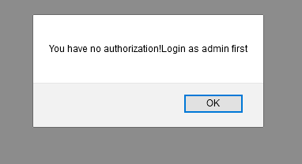

**After testing**

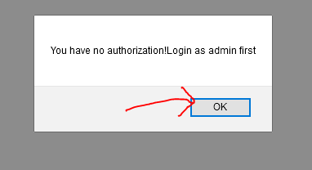

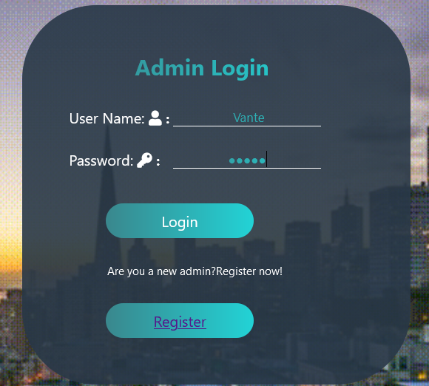

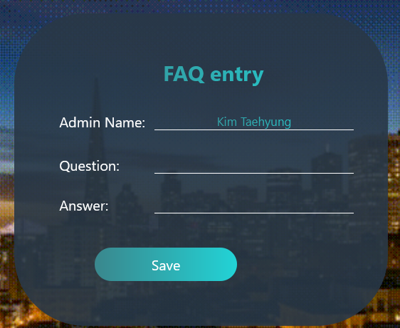

**Test case 5**

|  |  |
| --- | --- |
| Test objective | To be able to enter FAQ page after logging in first. |
| Test Data | User Name: Vante  Password: **** |
| Test Procedure | The Login form is filled with the correct admin information first. Then the login button is clicked. |
| Expected Result | The login success message must appear and then the FAQ page must be able to entered without the permission problem saying the admin to Login first. And the admin name in the FAQ form must be the logged in admin’s name. |
| Actual Result | As shown below. |

**Before testing**

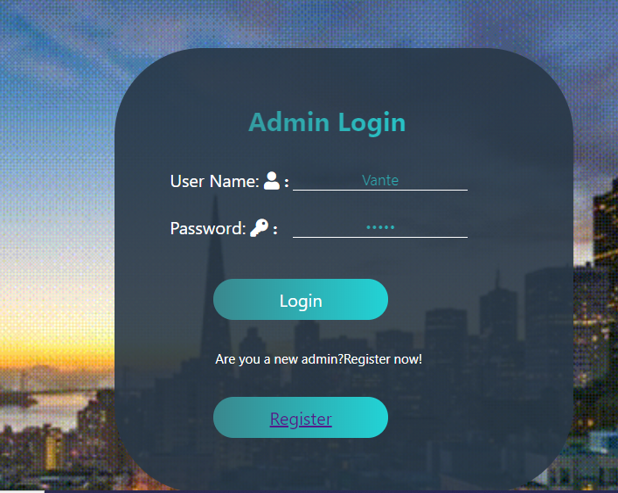

**After testing**

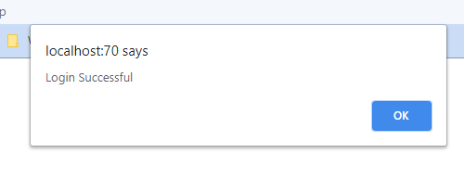

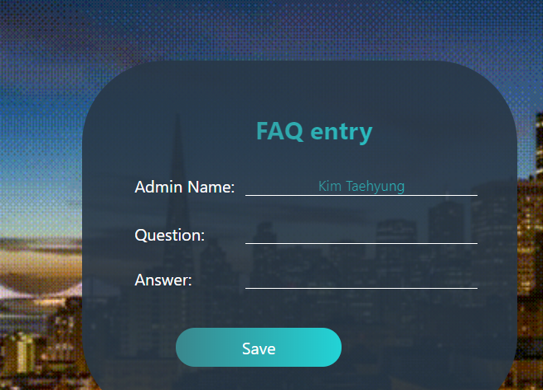

**Test case 6**

|  |  |
| --- | --- |
| Test objective | To show error message if the users enter the Contact Us page before logging in first and then to send the users to Login page. |
| Test Data | - |
| Test Procedure | The Contact Us page is entered without the users logging in first. |
| Expected Result | The message saying the users to Login first must appear once they click on the Contact Us page before logging in. After clicking ok on the alert box, the user must be sent to Login page. |
| Actual Result | As shown below. |

**Before testing**

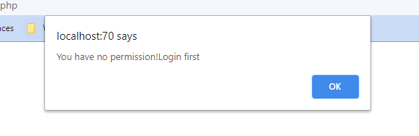

**After testing**

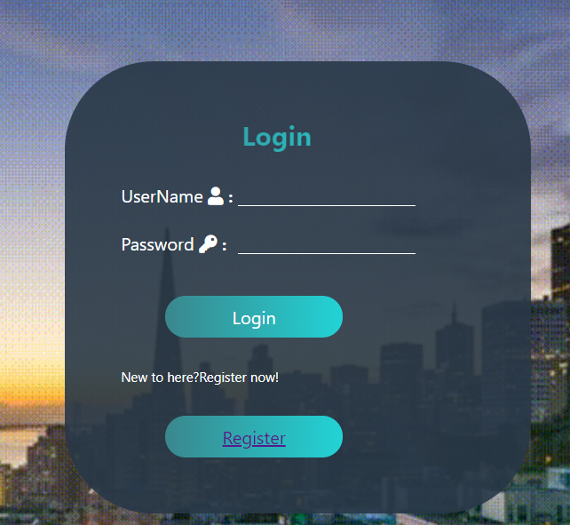

**Test case 7**

|  |  |
| --- | --- |
| Test objective | To be able to get into Contact Us page without the message box appearing and saying users to Login first after Logging in. |
| Test Data | User Name: Gillert  Password: Gillert |
| Test Procedure | The Login form is filled with the correct username and password. Then the login button is clicked. Next, the go to the contact us page. |
| Expected Result | The contact us page must run without the message saying the users to login first. Then the Asked by text box must be filled with the logged in user’s name. |
| Actual Result | As shown below. |

**Before testing**

 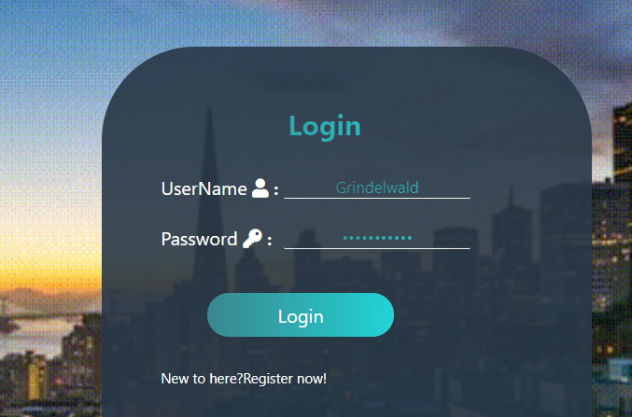

**After testing**

 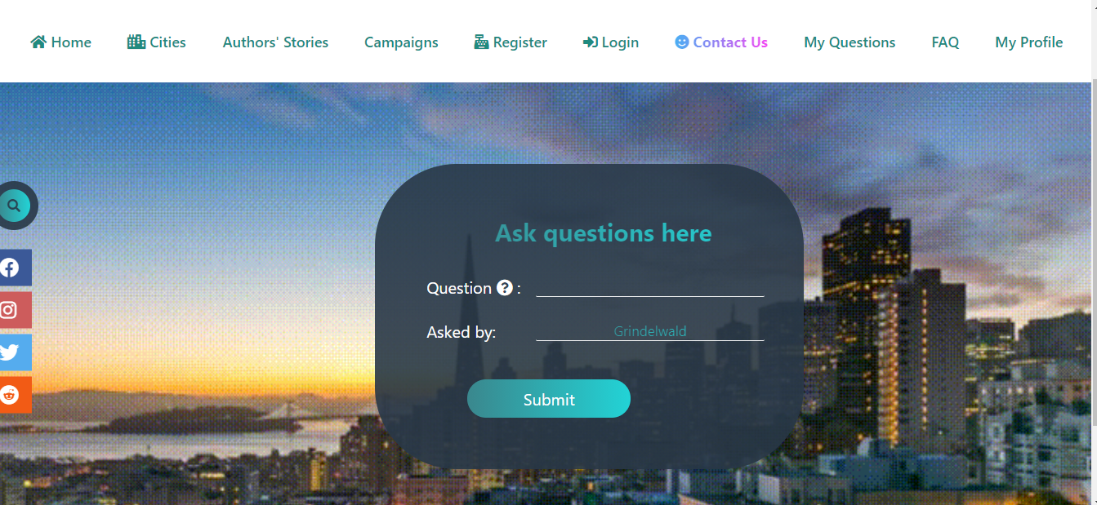

**Test case 8**

|  |  |
| --- | --- |
| Test objective | To get into the FAQ page after clicking the submit button in the Contact Us page. |
| Test Data | Question: How is WHO confronting air pollution effects on health?  Asked By: Grindelwald |
| Test Procedure | The question text box is filled with a question by the user. Then, the submit button is clicked to confirm the question. |
| Expected Result | The users must be directed to the FAQ page to find the question and answer there in case it exists. |
| Actual Result | As described below. |

**Before testing**

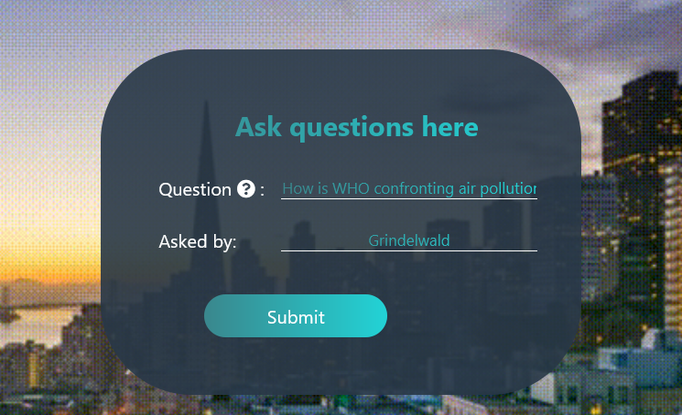

**After testing**

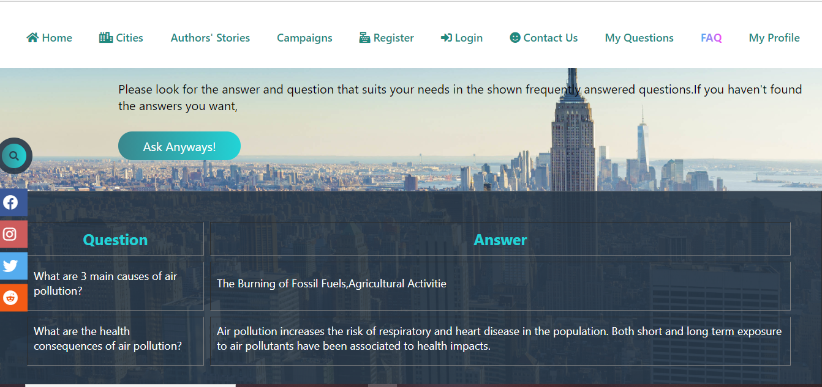

**Test case 9**

|  |  |
| --- | --- |
| Test objective | To be able to click the ask anyway button successfully and then the asked question and the user’s name must appear in the AskedQuesion page from admin’s side. |
| Test Data | Question: What are the most polluted cities in the world?  Asked by: Gillert |
| Test Procedure | The question is asked by the user and then the Submit button is clicked. Then the user is directed to the FAQ display place so that the user can find the required question in the shown Faqs. If the displayed Faqs do not meet user’s requirements, Ask anyway button is clicked. |
| Expected Result | The ask anyway button must be clicked successfully and after clicking it, the message saying “Question is asked” must be appear to inform users they have asked their question successfully. Then, that question must appear on the “Asked Question” page from admin’s side. |
| Actual Result | As demonstrated below. |

**Before testing**

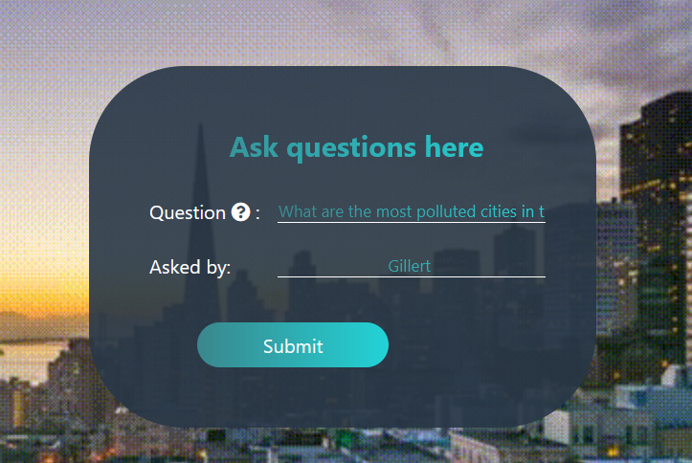

**After testing**

**Form User’s side**

 

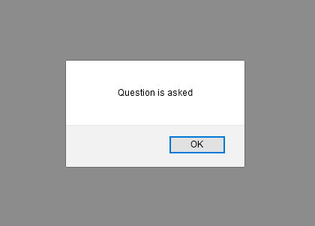

**From Admin’s side**

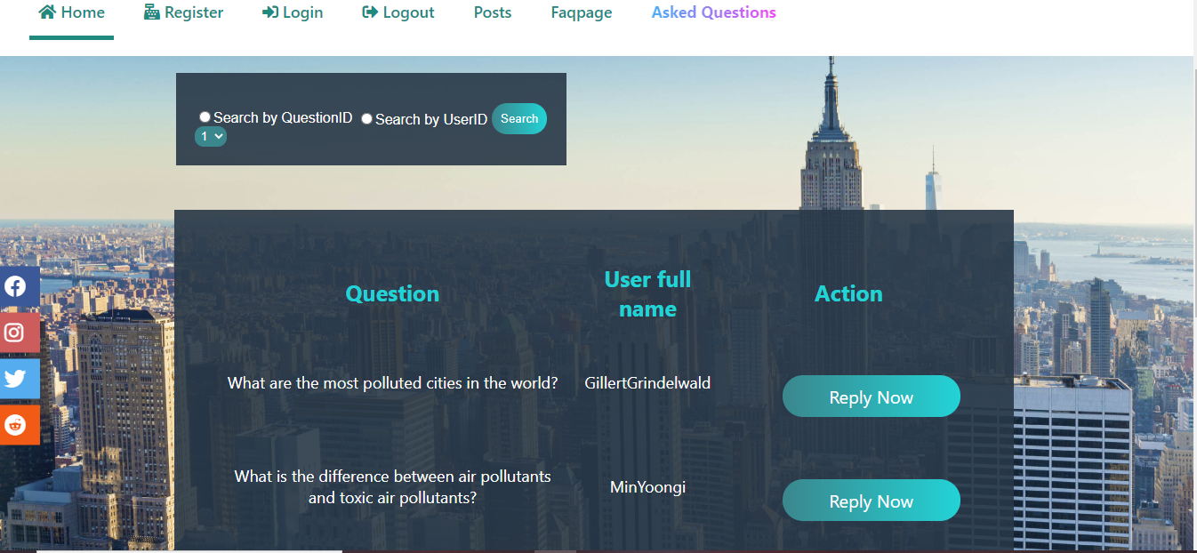

**Test Case 9**

|  |  |
| --- | --- |
| Test objective | To see the admin’s reply to user’s question from the user’s side Answers page. |
| Test Data | Question: What are the most polluted cities in the world?  Reply: Air pollution is very high in a number of Asian cities (Karachi, New Delhi, Katmandu, Bejing), in Latin American cities (Lima, Arequipa), and in Africa (Cairo).  Reply Date: 2020/8/27 |
| Test Procedure | The reply text box has been filled with the answer to the question shown above by admin. Then the Reply now button is clicked. |
| Expected Result | The message informing the admin that they have answered the question successfully must be appear after the reply button is clicked. The replied answer with the replied admin’s name and replied date must be displayed when the user enter the “My questions” page and click on the view answer button beside the asked question. |
| Actual Result | Can be observed below. |

**Before testing**

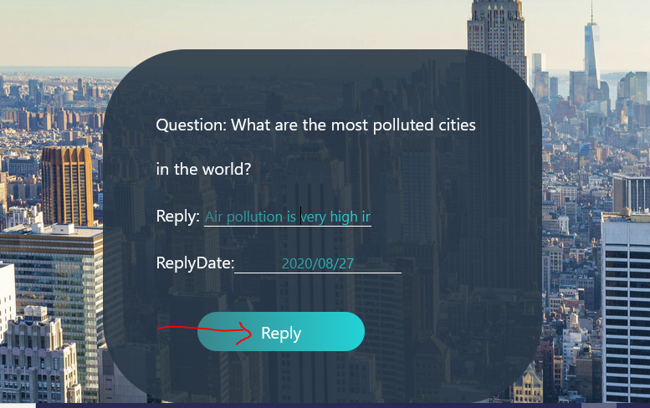

**After testing**

**From admin’s side**

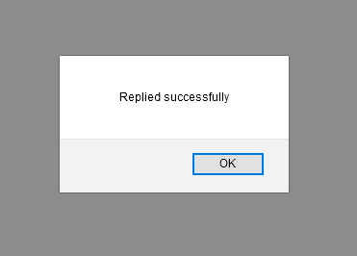

**From User’s side**

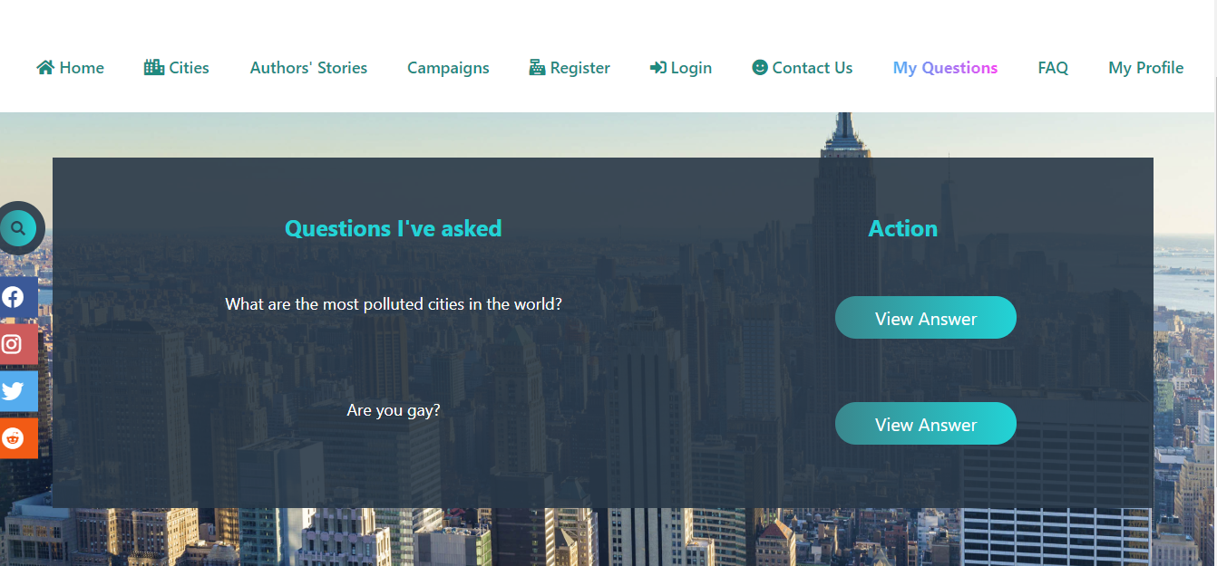

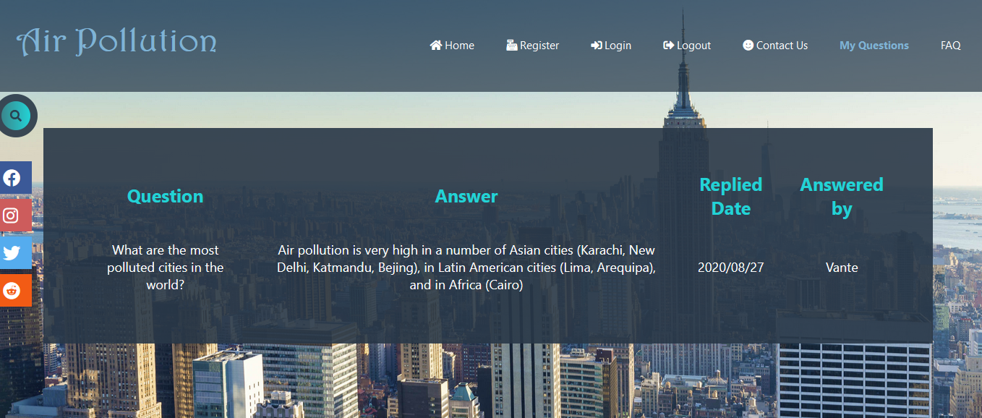

**Task 4**

# Task – 4

## Analysis

## Assumptions

## Screen Design

## Coding

Loreum Ipseum

## Testing

**Test Case 1(create Database)**

|  |  |
| --- | --- |
| Test objective |  |
| Test Data |  |
| Test Procedure |  |
| Expected Result |  |
| Actual Result |  |

Before Testing:

After Testing:

**Task 5**

# Task – 5

## Analysis

In this task, the users must be able to access into their search data. In this case, they need to be able to view their browsing histories and delete them if they wish to.

## Assumptions

The users can search the names of the cities they want to discover in the “City Display” page. Then, the searched data done by the users will be stored in the database and also will be displayed in the History page. In this case, the users should login first before entering the history page so that they will be able to see the search histories of their own. After logging in, the users will have the access to their browsing history page. There, they will be able to search their browsing history by the search terms or by the search dates. In addition, they will be able to delete those histories individually or all of them in one click.

## Screen Design

**CityDisplay.php**

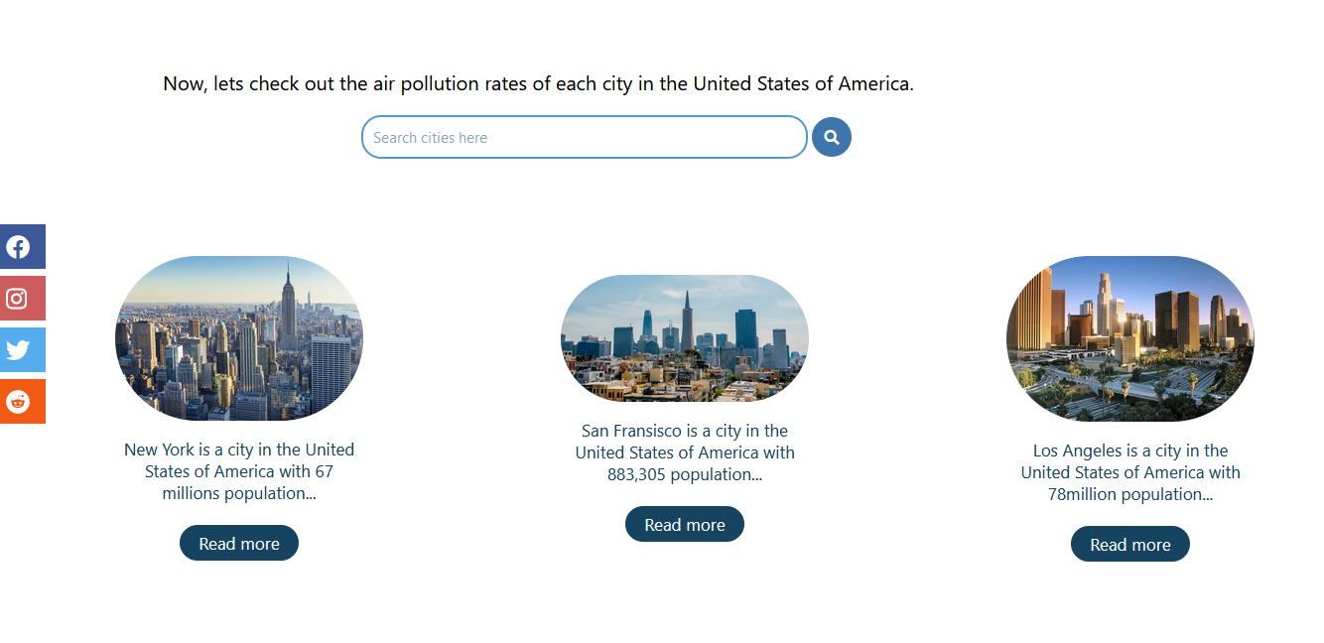

**History.php**

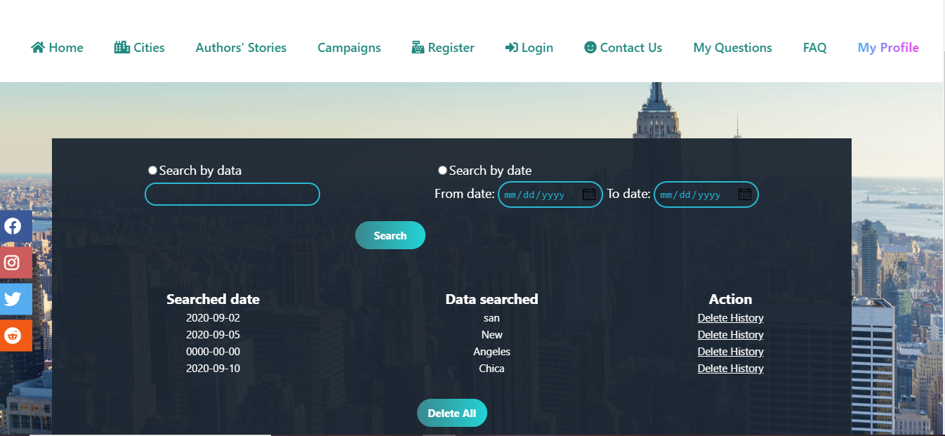

## Coding

**CityDisplay.php**

<?php

session_start();

include('Connect.php');

$Select="Select * from cities";

$selrun=mysqli_query($connect,$Select);

$crow=mysqli_num_rows($selrun);

if (isset($_REQUEST['btnsearch']))

{

$Search=$_REQUEST['txtsearch'];

$sel="Select * from cities where CityName like'%$Search%'";

$selrun=mysqli_query($connect,$sel);

$crow=mysqli_num_rows($selrun);

if (isset($_SESSION['UID']))

{

$userid=$_SESSION['UID'];

$search=$_REQUEST['txtsearch'];

$date=date('Y-m-d');

$insert="Insert into history (UserID,SearchData,Date) values('$userid','$search','$date')";

$insertrun=mysqli_query($connect,$insert);

}

}

?>

<html>

<head>

<meta charset="utf-8">

<title>Cities</title>

<link rel="stylesheet" type="text/css" href="Style.css">

<meta name="viewport" content="width=device-width, intial-scale=1.0">

<script src="https://kit.fontawesome.com/c8fd1d96f9.js" crossorigin="anonymous"></script>

</head>

<body>

<div class="dynamite">

<h1 class="title">Air Pollution</h1>

<input type="checkbox" id="chk">

<label for="chk" class="show-menu-btn">

<i class="fas fa-ellipsis-h"></i>

</label>

<ul class="menu">

<a href="Homepage.php"><i class="fas fa-home"></i> Home</a>

<a href="CityDisplay.php"><span><i class="fas fa-city"></i> Cities</span></a>

<a href="UserRegister.php"><i class="fas fa-cash-register"></i> Register</a>

<a href="UserLogin.php"> <i class="fas fa-sign-in-alt"></i> Login</a>

<a href="ContactUs.php"><i class="fas fa-smile"></i> Contact Us</a>

<a href="MyQuestions.php">My Questions</a>

<a href="FaqDisplay.php">FAQ</a>

<a href="viewprofile.php">My Profile</a>

<label for="chk" class="hide-menu-btn">

<i class="fas fa-times-circle"></i>

</label>

</ul>

</div>

<div class="icons">

<ul>

<a href="https://www.facebook.com/"><li class="facebook"><i class="fab fa-facebook"></i></li></a>

<a href="https://www.instagram.com/"><li class="instagram"><i class="fab fa-instagram"></i></li></a>

<a href="https://twitter.com/"><li class="twitter"><i class="fab fa-twitter"></i></li></a>

<a href="https://www.redditinc.com/"><li class="reddit"><i class="fab fa-reddit"></i></li></a>

</ul>

</div>

<div class="banner">

<img src="Images/newyork2.gif">

<p>If you are interested in learning more about the history of air pollution in the United states of america, <br><br>

<a href="https://www.epa.gov/air-trends/air-quality-national-summary"> <input type="button" class="visit" value="Visit Here"></a>

</p>

</div>

<div class="cities">

<p class="co">Now, lets check out the air pollution rates of each city in the United States of America. </p>

<div class="koo">

<form action="" method="post">

<input type="text" class="kootxt" name="txtsearch" placeholder="Search cities here">

<button type="submit" class="koobtn" name="btnsearch"><i class="fas fa-search"></i></button>

</form>

</div>

<div class="camila">

<?php

if ($crow==0)

{

echo "<p>No cities found.</p>";

}

?>

<div class="damien">

<table width="100%" >

<?php

for ($i=0; $i <$crow ; $i+=3)

{

echo "<tr>";

$csel2="Select * from cities limit $i,3";

$cselrun=mysqli_query($connect,$csel2);

$cselcount=mysqli_num_rows($cselrun);

for ($j=0; $j <$cselcount ; $j++)

{

$cfetch=mysqli_fetch_array($cselrun);

$cname=$cfetch['CityName'];

$cimg=$cfetch['CityImage'];

$pop=$cfetch['Population'];

$cid=$cfetch['CityID'];

echo "<td>";

?>

<img src="<?php echo $cimg ?>"> <br>

<p><?php echo $cname ?> is a city in the United States of America with <?php echo $pop ?> population...<br><br>

<a href="CityDetail.php?CID=<?php echo $cid ?>"><input type="button" class="camilabtn" value="Read more" class="camilabtn"></a>

</p>

<?php

echo "</td>";

}

echo "</tr>";

}

?>

</table>

</div>

</div>

</div>

</body>

<footer>

<p>CopyRight&copy;www.airpollution.com All Right Reserved | Privacy and terms of use | <a href="#"><i class="fas fa-at"></i> Email us</a></p>

</footer>

</html>

**History.php**

<?php

include('connect.php');

session_start();

$UserID=$_SESSION['UID'];

$hselect="Select * from history where UserID='$UserID'";

$hrun=mysqli_query($connect,$hselect);

$hcount=mysqli_num_rows($hrun);

if (isset($_REQUEST['btnsubmit']))

{

$SearchType=$_REQUEST['rdosearch'];

if ($SearchType=='data')

{

$Search=$_REQUEST['txtsearch'];

$select="Select * from history h, users u where h.UserID=u.UserID and u.UserID='$UserID' and SearchData='$Search'";

$hrun=mysqli_query($connect,$select);

$hcount=mysqli_num_rows($hrun);

}

if ($SearchType=='date')

{

$fromdate=$_REQUEST['txtfrom'];

$todate=$_REQUEST['txtto'];

echo $select="Select * from history h, users u where h.UserID=u.UserID and u.UserID='$UserID' and Date between '$fromdate' and '$todate' ";

$hrun=mysqli_query($connect,$select);

$hcount=mysqli_num_rows($hrun);

}

}

?>

<html>

<head>

<title>History</title>

<link rel="stylesheet" type="text/css" href="Style.css">

<meta name="viewport" content="width=device-width, intial-scale=1.0">

<script src="https://kit.fontawesome.com/c8fd1d96f9.js" crossorigin="anonymous"></script>

</head>

<body class="newyork">

<div class="dynamite">

<h1 class="title">Air Pollution</h1>

<input type="checkbox" id="chk">

<label for="chk" class="show-menu-btn">

<i class="fas fa-ellipsis-h"></i>

</label>

<ul class="menu">

<a href="Homepage.php"><i class="fas fa-home"></i> Home</a>

<a href="CityDisplay.php"><i class="fas fa-city"></i> Cities</a>

<a href="UserRegister.php"><i class="fas fa-cash-register"></i> Register</a>

<a href="UserLogin.php"> <i class="fas fa-sign-in-alt"></i> Login</a>

<a href="ContactUs.php"><i class="fas fa-smile"></i> Contact Us</a>

<a href="MyQuestions.php">My Questions</a>

<a href="FaqDisplay.php">FAQ</a>

<a href="viewprofile.php"><span>My Profile</span></a>

<label for="chk" class="hide-menu-btn">

<i class="fas fa-times-circle"></i>

</label>

</ul>

</div>

<div class="icons">

<ul>

<a href="https://www.facebook.com/"><li class="facebook"><i class="fab fa-facebook"></i></li></a>

<a href="https://www.instagram.com/"><li class="instagram"><i class="fab fa-instagram"></i></li></a>

<a href="https://twitter.com/"><li class="twitter"><i class="fab fa-twitter"></i></li></a>

<a href="https://www.redditinc.com/"><li class="reddit"><i class="fab fa-reddit"></i></li></a>

</ul>

</div>

<?php

if ($hcount==0)

{

echo "<h2>No history to see</h2>";

}

else

{

?>

<div class="poker">

<form action="" method="post">

<table width="100%" align="center" class="janis">

<tr>

<td><input type="radio" name="rdosearch" value="data" >Search by data</td>

<td><input type="radio" name="rdosearch" value="date" >Search by date</td>

</tr>

<tr>

<td><input type="text" name="txtsearch" class="niki"></td>

<td>

From date: <input type="date" name="txtfrom" class="minaj">

To date: <input type="date" name="txtto" class="minaj">

</td>

</tr>

<tr>

<td colspan="2">

<input type="submit" name="btnsubmit" value="Search" class="kendall">

</td>

</tr>

</table>

</form>

<table align="center" class="legal" width="100%">

<tr>

<th>Searched date</th>

<th>Data searched</th>

<th>Action</th>

</tr>

<?php

for ($i=0; $i <$hcount; $i++)

{

$hfetch=mysqli_fetch_array($hrun);

$uid=$hfetch['UserID'];

$sdate=$hfetch['Date'];

$data=$hfetch['SearchData'];

$historyID=$hfetch['HistoryID'];

?>

<tr align="center">

<td><?php echo $sdate ?></td>

<td><?php echo $data ?></td>

<td><a href="DeleteHistory.php?HID=<?php echo $historyID ?>" >Delete History</a></td>

</tr>

<?php

}

?>

</table>

<form method="post" action="DeleteHistory.php">

<p align="center">

<input type="submit" name="delall" value="Delete All" class="delete">

<input type="hidden" name="txtuid" value="<?php echo $uid ?>">

</p>

</form>

<?php

}

?>

</div>

</body>

<footer>

<p>CopyRight&copy;www.airpollution.com All Right Reserved | Privacy and terms of use | <a href="#"><i class="fas fa-at"></i> Email us</a></p>

</footer>

</html>

## Testing

**Test Case 1(create Database)**

|  |  |
| --- | --- |
| Test objective | To store the search data in the database and to display that data in the History page after the users search something in the search box. |
| Test Data | San |
| Test Procedure | The word “San” is filled in the search box. Then the search button is clicked. |
| Expected Result | Name of the cities that are start with the word “San” must appear. Then this data with the user name and search date will be kept in the database and also will be displayed in the History page. |
| Actual Result | Can be observed as shown below. |

Before Testing:

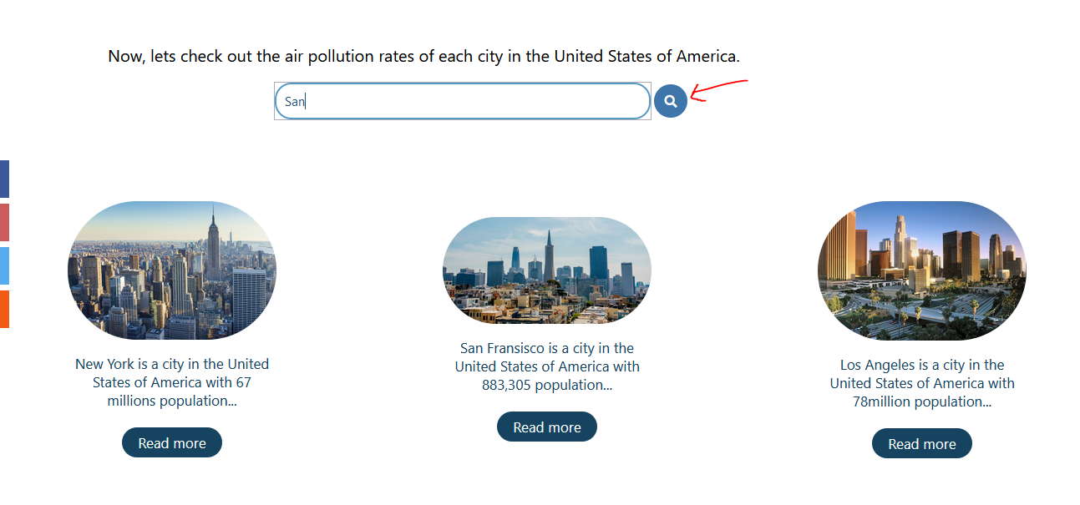

After Testing:

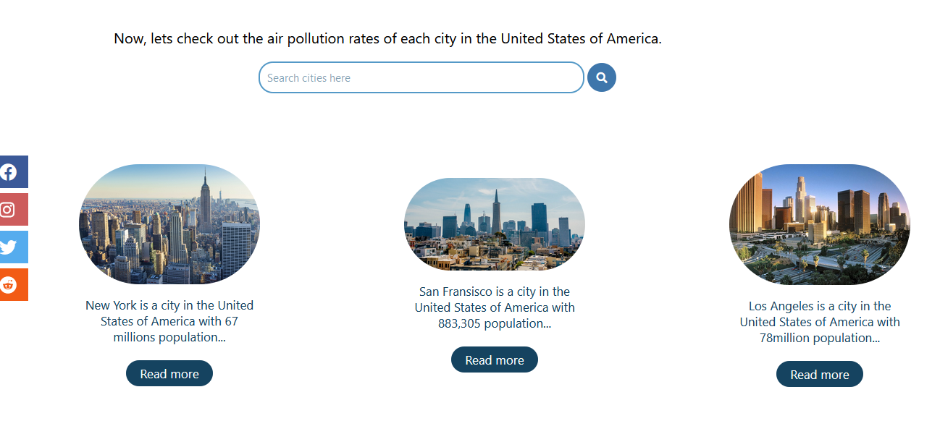





**Test Case 2**

|  |  |
| --- | --- |
| Test objective | To be able to delete the history |
| Test Data | - |
| Test Procedure | The user is logged in. Then in the view profile page, “My History” link is chosen to go to history page. Then in the History page, the “Delete History” link is clicked for one search term. |
| Expected Result | The chosen search data must be deleted and the deleted successful message must appear to inform users that they have successfully deleted the search data. |
| Actual Result | As displayed below. |

**Before Testing:**

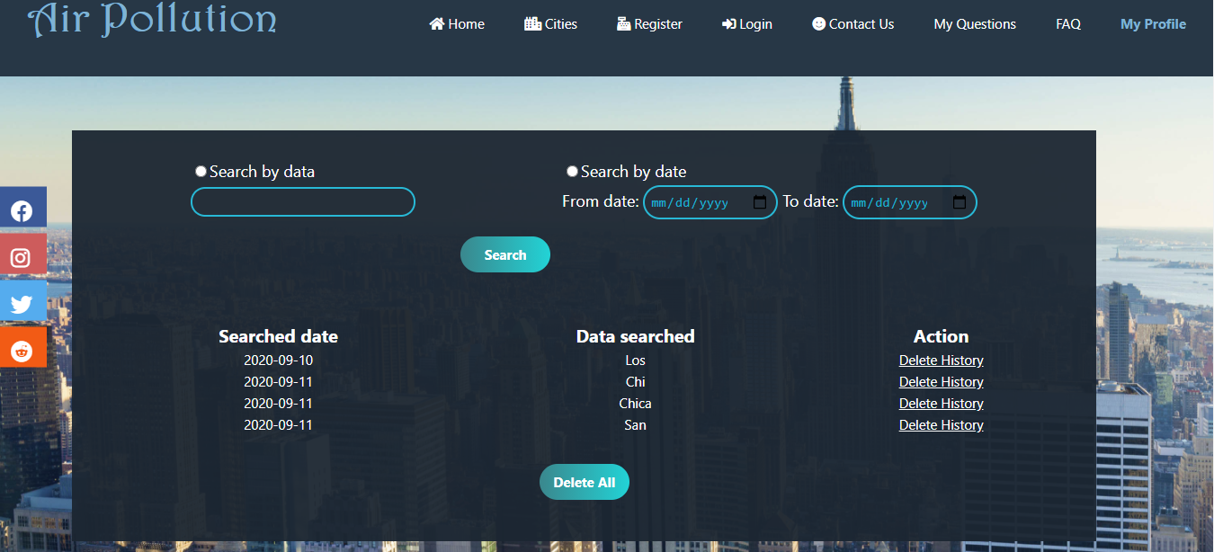

**After testing:**

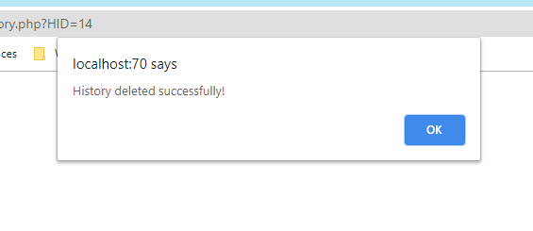

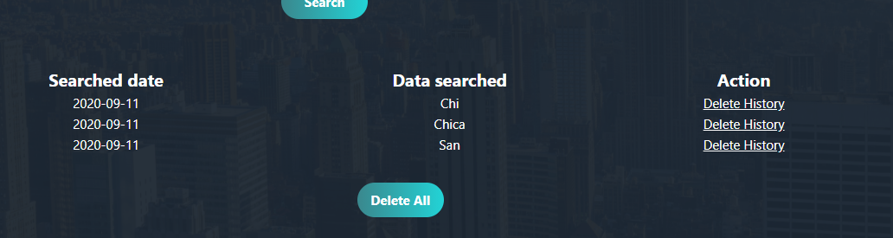

**Test case 3**

|  |  |
| --- | --- |
| Test objective | To be able to write posts by the admins and also the users can be able to see them after posting them. |
| Test Data | Title: Simple things we can do to save our planet  Content: Reduce, reuse, and recycle. Cut down on what you throw away. Follow the three Rs to conserve natural resources and landfill space.  Volunteer. Volunteer for cleanups in your community. You can get involved in protecting your watershed, too.  Educate. When you further your own education, you can help others understand the importance and value of our natural resources.  Conserve water. The less water you use, the less runoff and wastewater that eventually end up in the ocean.  Choose sustainable. Learn how to make smart seafood choices at www.fishwatch.gov.  Shop wisely. Buy less plastic and bring a reusable shopping bag.  Use long-lasting light bulbs. Energy efficient light bulbs reduce greenhouse gas emissions. Also flip the light switch off when you leave the room!  Plant a tree. Trees provide food and oxygen. They help save energy, clean the air, and help combat climate change.  Do not send chemicals into our waterways. Choose non-toxic chemicals in the home and office.  Bike more. Drive less.  Image: SaveOurEarth.jpg  Author: Kim Taehyung |
| Test Procedure | All the text boxes in the post form are filled. Then, the publish button is clicked. |
| Expected Result | The message informing the admins that their post is successfully published must be appear. Then the post must appear in the table under the Post form and also in the Post page in the “From our Authors” page from the user side. |
| Actual Result | As shown below. |

**Before testing:**

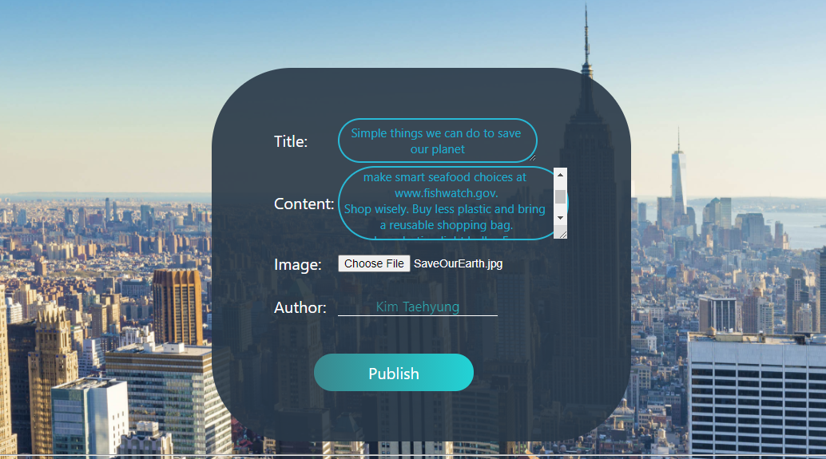

**After testing**

From admin’s side

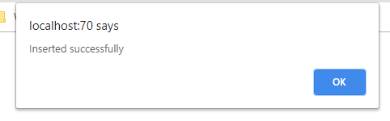

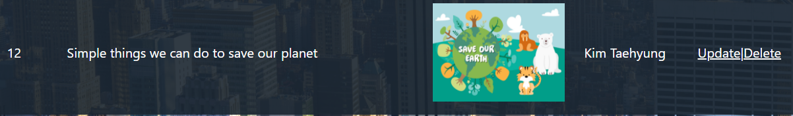

From User’ Side

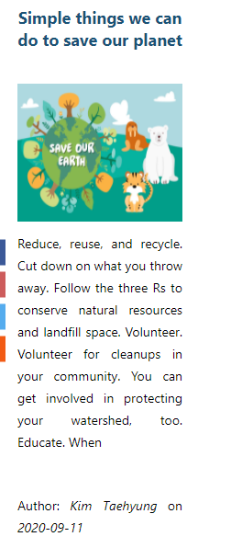

**Task 6**

# Task – 6

## Evaluations

Fkjdanfkadmfdks mdskmgdskg ms (Anon., n.d.)

# Bibliography

Anon., n.d. *What, so what, now what?.* [Online]   
Available at: https://www.futurelearn.com/courses/career-smart-sell-yourself/0/steps/25057  
[Accessed 31 May 2020].